Title of the Contribution
Initials and Last name ^{Affiliation no}, Initials and Last name ^{Affiliation no}, Initials and Last name ^{Affiliation no}, Initials and Last name ^{Affiliation no}, Initials and Last name ^{Affiliation no}, Initials and Last name ^{Affiliation no}
¹Affiliation, Country ²Affiliation, Country ³Affiliation, Country ⁴Affiliation, Country ⁵Affiliation, Country ⁶Affiliation, Country
Correspondent e-mail address
Enter the abstract in the gray area below (2000 character)

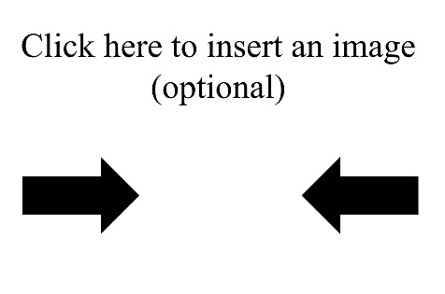
Figure Caption

