**[Project title here…………..]**

**This CEE funding is applied specifically to …subject……. The deadline is …………..**

**Note:** The maximum budget from CEE for this AI in Education community is €25.000,-

**Procedure:**

* After having received your application, CEE and 2 reviewers assess the application within three weeks after the submission deadline[1]. The start date is no later than ……. the end date is no later than ……………...
* The CEE-leader will check for consultation possibilities with CELT/TELT and other possible support if relevant.
* After the application has been reviewed, the project (team) contact person will receive the decision: accepted/minor revision/not accepted.
* The contact person is responsible for informing other stakeholders and making sure project (financial) administration and dissemination is taking place according to plan.
* Invoicing will take place as follows:
  + Within 3-4 weeks after the start of the project, a summary will be submitted for the 4TU.CEE innovation map (<https://www.4tu.nl/cee/innovation/>); this summary will be updated one week after completion of the project.
  + Funding can be invoiced after the project has been completed and at least one dissemination activity (other than final innovation map submission) has been carried out. Please note that final invoicing takes place by December 8th of the calendar year in which the project was ended.

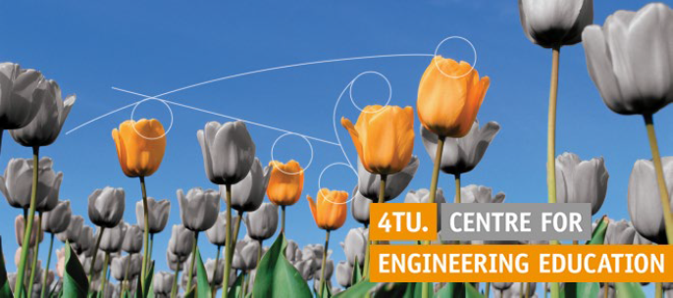

**Application form**

|  |  |
| --- | --- |
| Project goal and/or research question: |  |
| Project leader/researcher (contact person) name, and email address: |  |
|  |  |
| Other staff /people involved: |  |
| Project period (start and end date) and number of hours (of project work in total): |  |
|  |  |
| *Please provide a maximum 750 word project summary here, including information on all criteria given below*  *Expected outcomes*  *Time plan*  *Related to 4TU/CEE theme*  *Faculties involved*  *Evaluation*  *Involved other colleagues*  *Dissemination*  *Budget* | |

**Review criteria project approach**

Clearly state the expected outcome for

students in terms of their learning and/or wellbeing, including deliverables (e.g., module, tools…)

teachers, in terms of their learning and/or wellbeing, including deliverables (e.g., poster, website, video, tool…)

UT more broadly, in terms of knowledge and/or policy recommendations, including deliverables (e.g., poster, website, video, tool…)

Including a time plan

Relate the summary to one or more of the 4TU.CEE themes:

Challenge-Based learning

Teaching Excellence in engineering education

Entrepreneurial learning or academic entrepreneurship

ICT-enhanced engineering education and/or the digitally literate engineer

A minimum of 2 faculties are involved, by means of

Consultation/input

Collaboration

Other form, please explain briefly.

Include how project outcomes will be evaluated.

Explain how other colleagues in your faculties are planned to be involved (e.g., in data collection, in lunch meeting)

Include dissemination:

4TU.CEE innovation map is the minimum, and at least one other form, e.g., UT inspiration meeting, faculty lunch meeting, CEE-event/webinar, SEFI paper, journal paper…[2]

|  |
| --- |
| *Please indicate an estimate of on what and how the requested funding will be spent, using the criteria below* |

**Review criteria budget**

1. **Please note that a maximum of €25.000 can be applied for.** We cannot guarantee beforehand that the full amount requested will be granted even if your application is accepted.

Amount of hours spent and participants: please include a table including project member names, their faculty and department and total hours spent per person.

For the maximum amount of €25.000, 5-8 project members spend between 75-100 hours per person; however, deviations are possible if explained. Please note that this means some co-funding of your faculty/dept. is needed because the amount is not likely to cover spent hours in full.

The CEE-funding can be used to:

compensate for hours spent, e.g., by delegating tasks to others in your dept. or student assistants.

resources such as materials and/or software needed for the project

facilitate guidance/coaching, e.g. by CELT-employees or an e-learning specialist. Please note that each project is recommended to consult a CELT expert within the first 3 weeks of the project start and at least once mid-term; more may be indicated. You need to estimate a number of hours and CEE will consult CELT/TELT[3].

conference registration fee

Include how your faculties will provide co-funding, if relevant (e.g., whether you are allowed to spend more hours than covered with this application, whether student assistants or conference participation can be co-funded, software, and/or other), to make clear what the entire scope of the project is.

1.
2. TC/CEE are notified of dissemination plan before submission and/or consulted for dissemination events
3. If you want extra support apart from startup support and mid-term support, we cannot guarantee (complete) funding for this.