Feedback with impact and efficiency tips
Assignments are important to teach students to apply what they’ve learned and develop practical, academic and professional skills and higher cognitive skills, such as critical thinking. Assignments help students to better understand the subject matter and introduces students to real-life applications. Students learn to collaborate, work interdisciplinary and transdisciplinary, and merge their knowledge and skills into competences.
Providing students feedback is very important in this process, it helps them understand their strengths and areas for improvement, but when it comes to guiding students and assessing, it takes a lot of time and effort from the teaching staff. All the more important to look for ways to ensure that the provided feedback has impact and at the same time to look for ways to provide the feedback efficiently.
In the two checklists below we provide ideas and tips for both. But every teaching situation will differ. Browse the list and see what you already apply successfully and what might be useful ideas in your situation for the future. On the last page we provide some more sources with ideas and tips.
And don’t forget, you’re not alone in this! You don’t have to find out all by yourself. Ask your colleagues to share experiences, instruments, ideas etc. Browse sources. Spar with a CELT advisor or (if thinking about using digital tools) e-learning specialist.

Feedback with impact checklist - Points to consider

Characteristics of feedback with impact. This kind of feedback is:
- Intermediate. Provides opportunities to use for improvement.
- Focussed on the product/behaviour/performance (what is
observable; factual) not on the individual.
- Based on and related to clear objectives and criteria for success.
- Specific, understandable (check!), helpful (indication for improvement), encouraging.
- Descriptive, constructive rather than evaluative.
- Focussed on development, rather than on failure.
- Emphasising positive aspects as well as improvement points.
- Appreciative. Encouraging positive beliefs and self-esteem.
- Stimulating reflection and self-regulation and stimulates students to actively engage (fostering assessment literacy).
- Not overwhelming; focussed on the essential points or given step-by-step.

Before the assignment starts (feed up) – Points to consider: | I do | Nice idea
Explaining to the students’ what the feedback is for (for support, make them successful) and how to use it (in the specific setting). NB. This can be especially important in the first year. Discuss with the students their prior feedback experiences and how it influenced their work.
Formulate clear assignments. The better students know what to do, the more chance they will focus on the right aspects and be successful. Tips: How to Write Effective Assignment Instructions (short video); Transparent Assignment Design
Check whether the assignment is clear (Tip: Let a colleague check this.)? Describe the pur-pose, requirements (or conditions), how students’ work will be assessed afterwards. Also: possibilities to get help when questions arise. Preferably discuss the assignment in class.
Sharing the instrument for assessing students’ work (criteria list, rubric). Discuss this with the students.
Providing examples¹ of previous assignments (good ones, less good ones) with different grades and discussing these in class. Or let students assess these and come up with and discuss scores, grades and feedback they would give?
During the process (formative) – Points to consider: | I do | Nice idea
Discussing commonly made mistakes, pitfalls, in class.
Introducing or referring students to generic guidance (resources, support) on academic writing, essays, oral presentations, math etc¹. Preferably materials and sources they are already familiar with and which are used throughout the programme.
Establishing the link between what is covered in the lectures and in the provided literature and the assignment. This might seem obvious, but not always for the students.
Will you give students feedback during the process (formative feedback)? This can provide support and guidance, make the whole working process less overwhelming for the students and help students to make adjustments to improve their performance or deliverables during the process, which will enhance the quality of their work in the end. Feedback will have most impact when students can act upon it.
To consider: What kind of feedback will you provide? On the product and/or process? Will skills also be assessed? Afterwards and intermediate?
If students work in teams: Will you pay attention to the teamwork? Give feedback halfway and/or let students assess their working together halfway so changes can be made if needed. What kind of guidance will you give?
Do you have a design or protocol for the way the feedback process is set up? Indicating who will be involved (tutors? Peers? Self-assessment?)? At what moments? With what instruments or guidelines? Will it be provided in class or e.g. via Canvas? At plenary moments or by way of appointments with individuals or group of students separately.
Afterwards (summative feedback) – Points to consider: | I do | Nice idea
Do you provide feedback based on formulated assessment criteria? Or a rubric? Related to the learning objectives?
Formulating feedback in a way that students will understand it and are able to act upon it. Providing a possibility for students to discuss the feedback.
Explaining your judgements explicitly? Telling what is right/wrong but also why? Where relevant, referring to the expectations, learning goals and criteria.
If you use a rubric or form: Do you provide also a brief summary of your view of the work and/or process? To make it more personal an emphasis the important points.
Do you balance positive and negative comments? Does feedback highlight strengths of the work? Nb. Students don’t always realize what they did well and why it was good.
Explicitly indicating omissions (missing components) and requirements (e.g. deadlines or amount of pages) not met.
Making the feedback motivational, encouraging.
Posing questions that encourage reflection.
Do you explain your judgements? Telling what is right/wrong but also why? Referring to the expectations, learning goals and criteria? NB. It might it be beneficial to have a meeting with the students who failed to discuss the feedback. To ensure they understand what has to be done for repair.
Do you provide ways to improve or give attention points for a next time (feed forward)?
Do you offer students’ an opportunity to discuss the assignment and your feedback?
Evaluative – Points to consider: | I do | Nice idea
Asking students after the course or project (e.g. in a panel meeting) when and what kind of feedback during the module or course have helped them in the process. What kind of feedback did they value most / least? What have they missed or would they have liked?
Checking whether the provided feedback on Canvas was consulted (there might be ways to check this; learning analytics).
Making an analysis of the assignment result (analytical or more holistic, based on impression of the quality of students’ work). It provides insight in whether students made use of the (more generic given) feedback and what kind of information beforehand might be valuable a next time.

Timeliness | I do | Nice idea
Expectation management is key. Do you inform students when they can expect feedback?
To consider: Is the size and frequency of assignments within the module/course reasonable in relation to your (teaching team) ability to provide timely feedback (intermediate, in the end, based also on EER or R&R regulations for timelines)? Can it reasonably be organized? Are changes needed and to be discussed with the prog. director?
Can you use technology to support feedback provision? (Ask the faculty e-learning specialists or check Tool finder | Learning & Teaching Portal (utwente.nl)
Can you use feedback templates (rubric forms) to speed up (and standardize) feedback provision?
Engagement | I do | Nice idea
See some ideas before, e.g. let students assess work from previous student cohort (or a created piece of work) case) to get a feeling for the criteria and expectations. It can be done comparatively, e.g. let them order three pieces of work and explain why one is better than another. Discuss in this way the criteria and rubrics.
Or: Involve students in creating the criteria or rubric.
Idea: Providing the feedback without the grade first. Ask the student to check the feedback and relate this to the criteria or rubric. Reflect on this. Maybe come up with their own assessment of how they performed and discuss this.
Ask students to indicate how they made use of intermediate feedback (whether provided by themselves, peers or the teacher). This ensures that they will pay attention to it and can make reviewing later on easier.
Do you organize peer feedback moments? Advantage: Students get diverse feedback and will better understand the criteria.
If you use peer feedback, is the feedback from peers used and seen as useful by the students? Do you provide them with guidelines, instruments, and practice moments?
Is the feedback related to the learning goals and criteria? Do they use it for improvement?
Do you stimulate self-assessment? Advantage: Students get more aware of the criteria, reflect on their own work.
If you stimulate self-assessment, do you refer to the learning goals and criteria or rubric for this?
Can you provide feedback in different ways which can reinforce each other (e.g. plenary, verbal to the group, one-to-one, written feedback, self and peer based feedback)?
Idea: In combination with self-assessment for instance. Ask your students on what areas the feedback should focus. Or what kind of feedback they want or in what way.

__________________________________________________________________________________
The UT Language Centre offers support for writing but also other skills for students who need a bit more guidance. Support materials can also be found on Internet, for instance (examples thanks to VU): APA Sample Paper - Purdue OWL® - Purdue University; Academic Phrasebank | The University of Manchester; Worked out solutions for engineering and math topics: Math eBook: (ecoursesbook.com)
Feedback efficiency tips
NB. There is some overlap with previous list. Some ideas of the previous list, perhaps with some modifications or in combination, will also be useful for efficiency. In general, feed up (before the start of the assignment), feedback and feed forward (suggestions for improvements or a next step) with impact, will be beneficial for the end result and saves work when reviewing and leads to less repair assignments.
What we don’t address here is considering the assignment itself. Will another kind of product be an idea? For instance instead of a report of 20 pages, students write an advice memo of 3 pages. Or another way of presenting the learning results, such as by way of a video or PowerPoint with audio, instead of a written work. For ideas, see Alternative assessments | Assessment support (utwente.nl)

Feedback efficiency tips | I do | Nice idea
You’re not alone! You don’t have to find out all by yourself. Ask your colleagues to share experiences, instruments, ideas etc. Inspect useful sources. Spar with a CELT advisor.
Make sure the assignment description is clear. Communicate clear and high expectations. The better students know what is expected and what to focus on, the better they perform and the less (extensive) feedback will be needed afterwards for repair.
* See also previous tips on engaging students and feed up.
Make use of self-assessment for the students, based on criteria, a checklist, rubric or guiding questions, to stimulate reflection and help students to improve their work.
Make use of peer feedback (provide criteria, checklist, rubric or guiding questions). It improves the deliverables. Students can be asked to reflect on the feedback and indicate changes they made. This can be used as starting point for your feedback.
Provide (intermediate) generic feedback in class (and/or on Canvas). This can be done for instance based on some samples of intermediate products or drafts that were submitted.
When students deliver several assignments, only grade a random selection. NB. This has some pros and cons. See the explanation provided by the VU – CETL.
Use a rubric form on which you can mark cells and indicate specific points for attention.
Design a rubric or criteria checklist together with the students. They will get better insight in what is expected. Use it later on for intermediate (peer) feedback or self-assessment. Drafts or example work from previous years can be used to assist in this process.
Ask the students to check their work first (based on criteria, checklist, rubric or guiding questions) and then come up with specific points the want to get feedback on for further improvement.
Don’t give lengthy explanations in the feedback about things that were addressed in the course or in previous, related, courses. Refer to relevant materials.
Make the requirements clear from the start and also the consequences if they are not met. E.g. if you want X pages, you won’t accept longer papers. If you get a piece of work with many linguistic and grammatical errors, you indicate the errors on the first page to set the norm, and then let the student correct their work themselves. Distraction of points can be considered, as long as it is transparent for the students and requirements are about issues every student can be expected to fulfill.
Don’t give grades for intermediate deliverables, but just ‘completed’ or use a scale with just 3,4 or 5 standards, like e.g. “incomplete”, sufficient, good. This often works faster. Only if these verdict are contributing to the final grade, you have to come up with a way for transformation the intermediate verdicts to a total grade.
For longer projects with several drafts: give feedback the first time elaborately, also pointing out structure and language issues if necessary to show the expectations.
Use audio or video recordings for providing feedback.
If making comments in a text: Use macro’s (e.g. in Word or Excel) - standard text blocks – and create a master list of often used comments and explanations or model answers. Copy-paste these were needed.

Feedback efficiency tips | I do | Nice idea
If making comments in a text: Use a coding list. Just put in codes in texts and refer to an explanation list. Useful for less complex issues, standard errors or language mistakes. You can make it more personal by adding some personal comments at the start or end of the text. . For more explanation, see this [video]
Use markers in different colors and indicate their meaning. E.g. yellow = point to improve.
Ask students to organize their work in a way that will make it easier to provide targeted feedback. E.g. E.g. let them use a specific format or numbering paragraphs.

The checklists were originally constructed for the (UTQ//BKO) Testing & Assessment course, CELT/UT. Updated: Sept./Oct. 2024 (W.D.J. Vlas, coordinator/trainer/Assessor T&A course)

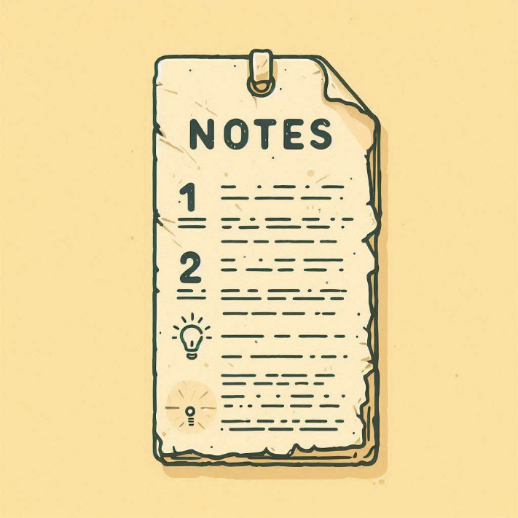
Now that you have gone through the checklist,
identify three points you consider to implement.
How will you go about this? Next time I will….
1)

2)

3)

Interesting sources

University of Twente sources
- An overview of available tools: Tool finder | Learning & Teaching Portal (utwente.nl) If you are working at the University of Twente and would like some support or just discuss possibilities, please turn to the e-learning specialist at your faculty or the Technology Enhanced Learning & Teaching group.
- CELT-site all about assessment: Utwente: Testing & Assessment
- To learn what is expected from all stakeholders involved in the assessment process: https://www.utwente.nl/assessmentpolicy
External sites about feedback on assessment
- Feedback on Assessments – Curriculum Framework (reading.ac.uk). Site with information about advantages and drawbacks for different ways to give feedback on assessments.
- Assessing Large Groups – Bristol Institute for Learning and Teaching Blog. Some general tips. Some more can be found on: Assessing Large Classes | UNSW Teaching Staff Gateway
- The Centre for Teaching Excellence of the University of Waterloo developed a useful webpage about fast and equitable grading.
- Top 10 tips on assessment for learning – University of Kent.
Peer assessment / peer review
- A lot of tips can be found on this site: Using Student Peer Review in Any Class | Centre for Teaching Excellence | University of Waterloo (uwaterloo.ca).
- Top 10 tips on Assessment for Learning. This resource provides a set of tips highlighting the importance of feedback and assessments, and how these can be best utilized in order to enhance and encourage learning.
Sites to use for students to support feedback literacy
- 10 top tips about feedback from students for students: Making-the-most-of-your-feedback
- Deliverable C - Guide How to Use Feedback Effectively - A guide for students
- Explanation and tips for students for making better use of feedback in their learning process. Learning from feedback (unimelb.edu.au)
- Step-by-step guide to tackling assessments » Open Polytechnic
- Learning from your assessment This resource offers advice for students on how they may make the most out of any comments (intermediate feedback) received.
- Feedback and reflection Tips for students involved in group work to learn how to provide and receive useful and constructive feedback.

