Preface

This manual is an attempt to make the VRlab accessible for colleagues and students. For more information or any question please contact the webmaster.

Introduction
In our VR Lab movements can be tracked with an optical system (VICON). This optical system uses cameras and image processing technology to track reflective markers (Fig. 1a). A number of hi-speed cameras (Fig. 1b) are placed around the stage. The cameras use infrared lighting to get hi-contrast images of the markers. Vicon then correlates the data from each camera to generate a three dimensional (3D) map of all of the markers. This results in a 3D reconstruction of the captured movement. This data can be loaded in different software programs, for example Matlab, to analyze the movements in terms of forward (e.g., joint angles) or inverse dynamics (e.g., forces, moments), or in graphical software tools to visualize the movements.

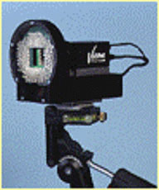
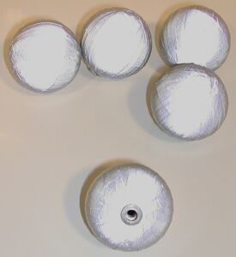

A. Reflective markers

B. Vicon camera
Figure 1

The main drawback of this optical technology is that each markers need to be seen by at least 2 cameras at any time to be interpolated correctly. Also since Vicon uses passive markers, they can't be differentiated, and post-processing analysis is needed to re-create the correct path of all the markers.
But right now, only optical systems can offer the range and number of sensors needed to track complex acrobatics and multiple actors contemporaneously.

Advantages | Inconvenients
Extensive range | No real-time feedback
Wireless sensors | Position data only
No distortions | Suffers from occlusion and noise
High number of sensors | Expensive

In order to capture movement in time and space you need a subject, a number of markers and Vicon. Once the hardware itself has been calibrated, that is when the recorded data from the markers corresponds to their physical position the markers are affixed to various points on the subject. Before capturing it is important to know what movements you want to capture and which marker configuration is needed to accomplish that. For example, for a 3D reconstruction of a knee angle at least 3 markers are required one of which located on the so-called bony landmark of the knee. This marker configuration has to be defined in a ‘markerfile.mkr’ (see …). A lot of marker configurations are defined already and can be found in the following folder on the ‘Vicon computer’ in our Vrlab C:\Program Files\Vicon\Models

Note that the reflective properties of the markers diminish considerably when the markers are damaged or dirty. Make sure your hands are clean and treat the markers with care!

Preparations of measurement

Let’s start at the beginning: starting up the computers en the workstation software and make sure there is enough available free space (VICON does not warn but just doesn’t save your data when the disk is full):

Start up the computers

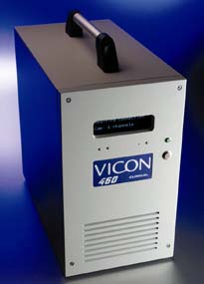
- Start the Vicon Workstation computer (Fig. 2) and the Vicon PC.
Figure 2. Vicon Workstation
- Start the workstation program by clicking the “Workstation” icon on the desktop of the vicon pc.
- Activate the cameras by clicking on the camera icon on the tool bar of the workstation program, or from the menu (System→Start Link) preferably about 15 minutes before starting the experiment.

Camera calibration

- Position the L frame on the platform. The global axes of the measuring volume are defined by the position of the L-Frame (Fig. 3) on the platform. The L-frame lies in the cupboard on the right . Usually the L-frame is placed on the center of the platform as is shown in figure 4B.
- Have a look at the measuring volume
  - Click System→Live Monitors. Clicking on each of the numbers will show you what the corresponding camera sees
Verify if there are no unwanted (not being the reflections of the markers on the L frame) reflections. If there are any, try to locate them with and remove them.
- Start the static calibration
  - Click “System” → “Calibrate Cameras” → “Calibrate (Static calibration)” → “Start (stops automatically)”

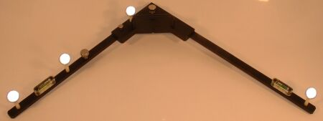
Figure 3. L-Frame

‘Visual wall’
L-Frame
Platform
‘Visual wall’
Motion platform
Force-plate
L-frame
A
B
Figure 4. (A) Top view of the position of the L-Frame on the platform in the VR-Lab when used for the surf demo (B) Top view of the position of the L-Frame during experiments. The corner of the L-Frame is aligned with the lower left corner of the force plate..

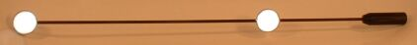
- Remove L-Frame and prepare the wand ( ) to capture the measuring space. The wand is also lying in the cupboard on the right
- Start the dynamic calibration
  - Hit Start (Dynamical calibration) and start waving, slowly, covering the whole area.
  - Hit Stop and stop waving. (If you’re all by yourself place the wand in the measuring area and then hit Start. When you are finished leave the wand in the area and hit Stop).
- Wait for the processing and watch the mean residual (preferably around 1mm and < 2mm) and the reproducibility (< 2%). Whenever the text failed shows up behind one of the cameras. The calibration has to be performed again. But first try to find out what the problem is with the camera. I.e. does the camera see any unwanted reflections
- Click → Accept
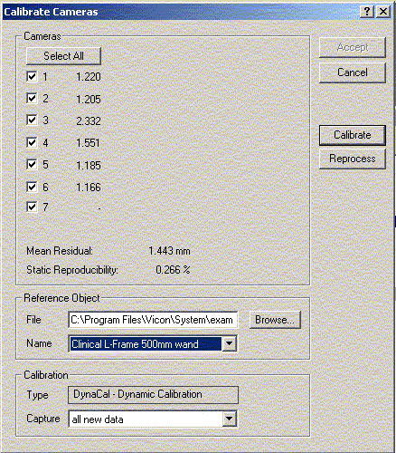
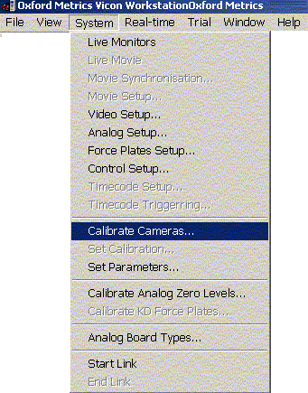
Example.cro
< 2mm
< 2%

Open a database

By default the software will automatically open the session (database) used the last time. There are 3 options
- Use this database, if you created it earlier or if you are allowed to use it
- Open an existing one (“File”→”Open Database")
- Create a new database
  - Click “File”→”New Database…”

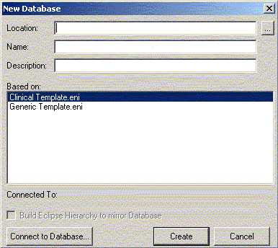
Select Clinical template.eni
Browse for a folder
Name of new folder in above selected directory

  - Click “Create” to create a new Database
  - Click yellow icon (below ‘File’) to view the database window
  - In database window:
    - Click green icon: new patient/subject classification
      - Tip: give this level a name related to the experiment
    - Click yellow icon: new patient/subject
      - Tip: give this level the name of the subject/patient
    - Click grey icon: new session
      - Tip: give this level the name of the current date
- Double click on Session to make sure you are in the right session and to be able to perform a capture

Setting up analog channels

- Double click on the Session/Patient concerned to make sure that the settings are applied to the whole Session/Patient and not to just one trial.
- Click “System”→”Analog” setup to check the settings
  - For measurement with the force plate, channels 1 -6 have to be checked (a cross at the start of the line) and the MiniAmp has to be switched on
  - For measurements with the force shoes or the sensor plate (force plate with 4 sensors), the channels 7-30 have to be checked and the power supply (switch at the back of the rectangular black-box) for the amplifiers has to be switched on.
  - For other analog channels, connect them to one of the channels on the patch box (don’t use channels 7-30 if you are also using the force shoes or sensor plate) and check the corresponding number. If desired you can give the channel a name. Use channel 31 for a synchronisation signal
- Set the sample frequency of the analog channels, this should at least be the same as the sample frequency of the cameras (120 Hz).

Force plate setup

Check the position of the force plate “System”→”Forceplate setup”. Normally this position is’t changed and furthermore Vicon is calibrated with respect to the force plate. The position should be….

Calibrate analog zero levels

The last step before capturing real data, is to calibrate the analog zero levels, or with other words, determine the offsets of the force plate. This should be done in the configuration in which you are using the force plate/sensor plate/other channels. So if you are going to use the mall, attach it to the force plate before determining the offsets. In this case the weight of the mall is part of the offsets!
- Double click on the Session concerned to make sure that the settings are applied to the whole Session and not to just one trial.
- Click “System”→”Calibrate analog zero levels”
- Check what you would like to calibrate (Force plate and/or Other channels)
- Press “Calibrate”
- Check again what you just calibrated (otherwise the determined offsets are not applied, but just calculated)
- Press OK

A good practice is to verify whether the calibration succeeded, especially for the force plate and sensor plate. This can be done by capturing about 10 sec. of analog signals (see next part for information about capturing) when nobody is standing on the force plate/sensor plate. Subsequently the measured analog signals can be examined by opening the trial and click “Graph”→”Analog signals” and select one of the channels. A graph is shown with in the corner the average and standard deviation of the signal. The average of all signals should be around zero (>-5 and <5). If this isn’t the case, try the calibration of the analog zero levels one more time.

Conduct Vicon measurements

Capture

After the system calibration a subject has to be defined and the correct marker configuration has to be attached. The general way to do this is by performing a Static subject calibration. The subject calibration is meant to define the positions of the different markers with respect to each other. For the static calibration it is essential that at least during a part of the trial ALL markers are visible. Furthermore the static calibration can be used as reference position.

Static subject calibration (Subject Capture)

- Click “Trial”→”Capture”
  - Specify the Trial name.
N.B. It is a good practice that the date and name of the subject form part of your trial name and to end the name with the trial number, starting from 100. For example. <yymmdd><subjectname><trialnumber>. It is advised against to use the trialname for a description of your trial. Use the "experiment logboek" to keep a list of description of your trials. It is possible to use the trial number to make a distinction between different conditions, i.e numbers 101 and onwards for trials with eyes open and 201 and onwards for trials with eyes closed
  - Select the subject.
  - Check the Trial Type. Use subject calibration or one of your own predefined trial types (Click “Tria”→”Trial Types”→new and define your own settings). After your selection, the setting of the trial type will be displayed in the window. For the subject calibration the trial duration is set to 3 s.
  - Click “Capture”→”Start”
  - Click “Stop” if the duration is not predefined.
- Save trial
  - Click “File”→”Save”
  - Or press the save icon on the toolbar

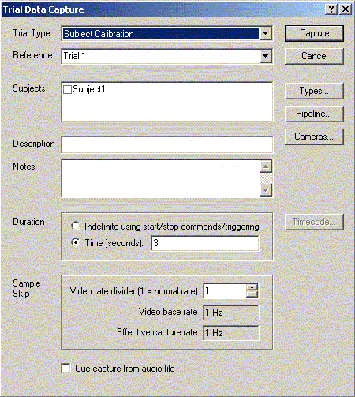
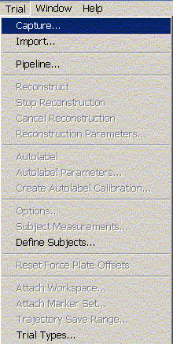
120Hz
120Hz

For the static calibration it is very important that all markers are visible at one moment. This has to be assessed before proceeding to the dynamic trials. For this purpose the markers have to be reconstructed. This is done automatically when you chose the subject calibration otherwise click “Trial”→”Reconstruct”. After reconstruction the markers will be shown in the 3D editor. In the lower left hand corner a reconstruction number appears. This number (indicating the number of reconstructed markers) tells you something about the quality of the calibration. If it is much higher than the amount of markers attached to the subject(s), you may reconsider the marker positions, camera sensibility etc. (You can zoom in and turn around your subject by manipulating the mouse/right button). Check if ALL markers are visible at the same time by sliding over the time bar. If this is not case you first have to find out why this is not to case before repeating the static trial. Note that sometimes at the beginning of the capture not all markers are visible. More information about reconstruction and further processing of the static trial can be found in Chapter 4.

General Capture

- Click “Trial”→”Capture”
  - Specify the Trial name (use the naming directions as stated in the static trial capture).
  - Select the subject.
  - Check the Trial Type. Use general capture or one of your own predefined trial types.
  - Click “Capture”→”Start”
  - If the trial duration is set to indefinite or if concerned data is collected hit “Stop”.

Vicon workstation stores the raw data in 2 separate file. The marker data are stored in a TVD file and the analog data are stored in a VAD file. Further processing is needed to get to reconstructed and labeled marker data in the C3d format. This process is described in the next chapter.

Process data to reconstructed and label marker data

Reconstruction
Reconstruction has been shortly described in the paragraph 3.1.1. The aim of reconstruction is to transform the 2D image of the 6 cameras into 3D positions of the markers. For some trial types reconstructions is done automatically (like in the subject calibration), otherwise a trial can be reconstructed manually by opening the trial and clicking “Trial”→”Reconstruction” on the menu. The reconstruction leads to a number of reconstructed trajectories. In the ideal case this number is equal to the number of markers attached to the subjects. If this is not the case, there are 2 possibilities
- The number of reconstructed trajectories is smaller than the number of attached markers.
  - One or more of the markers was not visible during the whole trial. Repeat the trial and assure that all markers are visible
  - When a marker should logically be visible, but is not reconstructed, you can try to change the reconstruction parameters (Click “Trial”→”Reconstruction Parameters”). First try to change the intersection limit from 12 to 10 or 7. Changing other parameters is a rather complex process, so first refer to the Vicon 2003 Manual before doing this.
Important:
Whenever you adapt reconstructions parameters take care to return the values to their original values before you turn off the computer.
- The number of reconstructed markers is larger than the number of attached markers.
  - One marker has more than one trajectory, because the marker was obstructed one or more times during the trial.
  - There are ghost markers (markers which appear in the measured volume but are not part of your marker setup) in the measured volume. If these markers are close to the measured subject there is not much you can do. However if there is a clear distance between the subject and the ghost markers you can get rid of them by adapting the reconstruction volume (click “View”→”Reconstruction Volume” to see the reconstruction volume) , click “Trial”→”Reconstruction Parameters” and adapt one of the limits in X (left-right with respect to the computers), Y (front-back) and Z(up-down) direction.

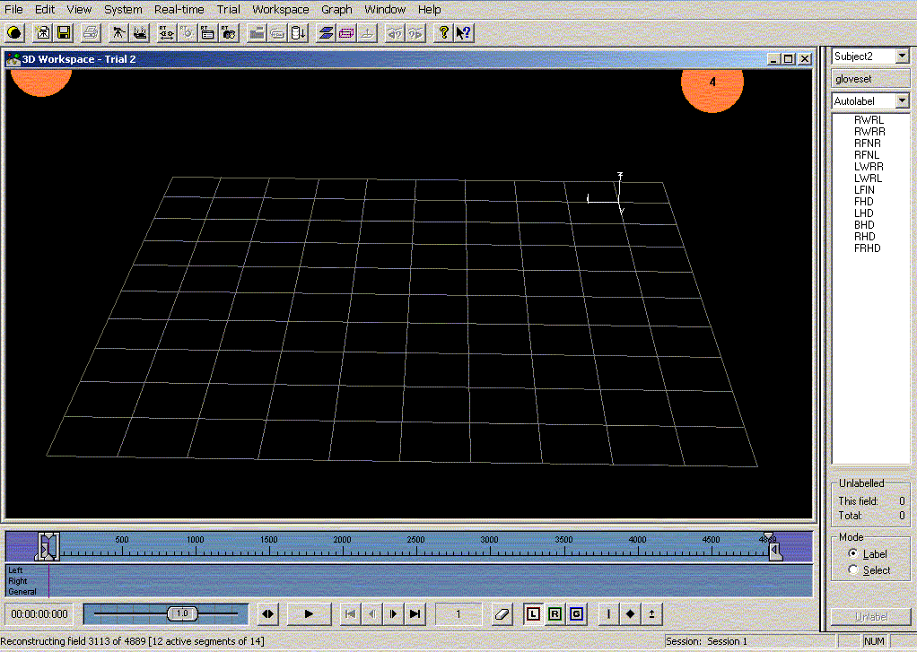
markerset (.mkr)
Reconstructing markers process
Reconstruction Process
Camera 4
labeled markers in markerset
# reconstructed markers
time (# samples)

Labeling

The next step is to assign a name to the reconstructed trajectories.
- Define your subject. (There are a couple of options to do this)
  - Select the subject in the Data Trial Capture window.
  - Click “Trial”→”Options” and select the subject you want
  - Click “Trial”→”Options”→”Subjects” to define a new subject

- Attach a marker set to your subject.
  - Click “Trial”→”Attach marker-set for …” (the marker sets are .mkr files and are stored in C:\Program Files\Vicon\Models. You can make your own markerset for more information see …). The loaded marker-set will appear at the right

- Label the trajectories. Select the markers with a left mouse click in the same order as defined in the marker-set. Tip: select all markers (deselect with your right mouse button), and subsequently select the first name in the marker set and then use the ‘down arrow’ to select all following names. Any possible errors in labelling can be undone by
  - Click “Edit”→”Undo” or <CTRL+V>
  - Click the incorrectly labelled trajectory and subsequently click “Un-label”
  - Click the incorrectly labelled trajectory and subsequently the appropriate name in the markerset.

- Remove ghost markers, these markers remain unlabeled.
  - Click “File”→”Delete unlabelled”
N.B. this is very important for it will save time and problems when reading c3d files in Matlab!

- Defragent trajectories or with other words combine the different trajectories (when there are more than one) belonging to one marker to one trajectory
  - Click “File”→”Defragment Trajectories”

A window pops up, telling how many trajectories are generated and how many joints are made between the different trajectories to reach the total number of trajectories. The total number of trajectories should be equal to the number of markers in you marker set, if this is not the case there are a couple of options
  - Less trajectories than markers in your markerset
    - One of the markers was obstructed/not visible during the entire trail. If the marker should be visible refer to the Vicon 2003 manual to adapt the reconstruction parameters.
  - More trajectories than markers in your markerset
    - The unlabeled trajectories were not removed. Remove them now and click defragment trajectories one more time to check the number of trajectories
    - Overlapping trajectories were created (when manual labelling this is mentioned in the pop up window). This means that at some samples during the trial, one marker has more than one trajectory/position. Of course this is not possible and the overlapping trajectory should be deleted
      - Click “Graph”→”New continuity chart”
      - Scroll down, the overlapping trajectories are at the bottom of all trajectories and indicated with the marker name followed by the number of the overlapping trajectory (i.e. RASI-3 For the 3rd overlapping trajectory of the RASI marker).
      - Select the trajectory (scroll to the right till you find the lines belonging to the marker and left mouse click on these lines)
      - Click “Edit”→”Delete trajectory” or “Delete Multiple trajectories” if you selected more than one overlapping trajectory.

N.B. It is very important that the c3d file does not contain more trajectories/markers as defined in your markerset, for using the files in Matlab.

Markerset
To label your markers and create a stick figure you need to attach a markerset in which the markers are defined and the relation/hierarchy between the markers. Depending on the marker configuration you used to capture your data you either select an existing markerset (in C:\Program files\vicon\models) or you’ll have to make your own (preferably based on a existing one) and save this new file in C:\Program files\vicon\models. The markerset is defined in the so called .mkr file. The structure of this .mkr file is explained below on basis of an example. The bold text is explaining text and is not part of the .mkr file.

Always start with the following two lines
!MKR#2
[Autolabel]

Define your markers by stating their names with a short explanation
LSHO left shoulder
RSHO right shoulder
SACR sacrum
LASI Left ASIS
RASI Right ASIS
LTHI Left thigh wand marker
LKNE Left knee
LTIB Left tibial wand marker
LMAL Left malleolus
LTOE Left toe
LHEE Left heel
RTHI Right thigh wand marker
RKNE Right knee
RTIB Right tibial wand marker
RMAL Right malleolus
RTOE Right toe
RHEE Right heel

Define your segments by stating which markers belong to a specific segment
UPPERTRUNK = RSHO,LSHO,SACR
LOWERTRUNK = SACR,RASI,LASI
LEFTUPPERLEG = LASI,LTHI,LKNE
RIGHTUPPERLEG = RASI,RTHI,RKNE
LEFTLOWERLEG = LKNE,LTIB,LMAL
RIGHTLOWERLEG= RKNE,RTIB,RMAL
RIGHTFOOT = RMAL,RHEE,RTOE
LEFTFOOT = LMAL,LHEE,LTOE

Advances features

For advanced features like autolabeling, real time monitoring, refer the Vicon 2003 Manual.

Appendix’s

Appendix A:
Nomenclature and icons for Generic, Science/Engineering and Entertainment data templates.

A Trial is the name given to the data capture process and the group of files in
which the data is stored. The other levels or nodes are different ways of
organising your data. These can be thought of as being similar to folders in the
Windows file system, though the difference is that they contain different kinds
of data and the data hierarchy is strictly maintained. For example you can move
data around using the Data directory, but you can only ever put Trial data in a
Session or Sub-session, and a session in a capture day or patient level.
Expanding the window you will see other information is also displayed as shown
in the figure below.

Appendix B:
A section across the Eclipse Data Directory:

- To open a trial:
• Double click the text e.g., Trial 1or the adjacent trial icon

If both movie and processed data are stored in the trial, double clicking the Trial
icon opens both windows. If you wish to open only one type of data then you can
do this by double clicking one of the icons to the right.

Appendix C:
Mouse control of the 3D Workspace

Appendix D:
Viewing Analogue Data.

Analogue data, such as that from force plates used in Gait Analysis is displayed
in the “Analogue Data window”:

• Select “Window”→”New Analogue Data”
Each row displays a single channel of analogue data. You can expand and
contract both the time and gain scales:
• Select a channel either by clicking on the channel number or by using the up
and down arrows on your keyboard.
• Press G to expand the Gain
• Press T to expand the Time scale
• Press Shift + G to contract the Gain scale
• Press Shift + T to contract the time scale
• Press L or Shift + L to increase and decrease the number of channels to
display in the window

Note that the Gain changes only for the currently selected channel. Time scale
changes for all channels.

