IMPACT CASE TEMPLATE

ABOUT THIS TEMPLATE
This template was initially created for a workshop on impact cases conducted at the High-tech Business and Entrepreneurship (HBE) department within the Faculty of Behavioural, Management, and Social Sciences (BMS) at the University of Twente in January 2024. The template builds on work by the University of York, the University of Bath, the University College Dublin and Nyenrode University.

Contributors:
- Dr. Letizia Alvino (HBE-ETM)
- Prof. Dr. Louise Knight (HBE-ETM)
- Ir. Tom Boogerd (Research Support Office)

Last edit: March 2024

WRITING TIPS

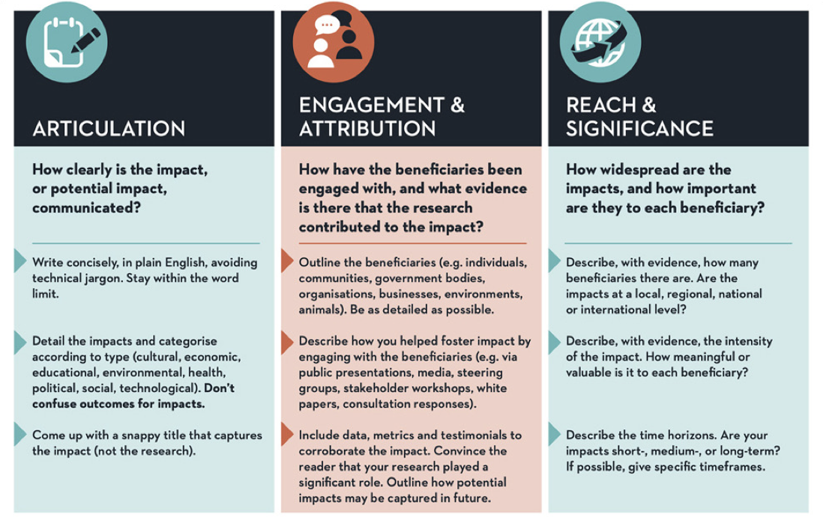Source: UCD Dublin

The template starts on the next page

IMPACT CASE TEMPLATE

A. GENERAL INFORMATION

Author name(s):

Other contributors/partners:

Title of the Impact Case:

B. EXECUTIVE SUMMARY OF THE IMPACT CASE

Approximately 150 words. You are advised to work on section C first.

Introduce your topic:
- What new knowledge and insights were generated,
- Which communities/stakeholders were impacted by your efforts and how.
- How was your impact developed over time (if possible, provide a timeline).

Focus on the change that has occurred (impact) and tell the reader what you are about to describe to them. Be bold and focused. This section should briefly state what specific impact is being described in the case study.

------------------------------------------------------------------------------------

C. DISCUSSION OF THE IMPACT

Approximately 500 words.

The following question provide a guideline to define your impact case:

- Topic. Describe your topic. Specify if this is the result of a single project or a combination of multiple projects with a shared goal. What was your contribution to the project(s)?
- Problem Identification. What was the problem/opportunity addressed? And why it is/was a problem?
- Uniqueness of the topic described. What makes this project/topic unique? What makes this project/topic important?
- Identify communities/stakeholders. Who has benefitted from your work?
- Specify the benefits to communities/stakeholders. How have they benefitted from your work?
- Discuss Evidence. What evidence could make this explicit?

------------------------------------------------------------------------------------

D. REFERENCES GENERATED AS A RESULT OF THE RESEARCH

Include a maximum of 10 references (e.g., grants or follow-up grants, journal articles, book or book chapters, newspaper articles, given talks, …, ….). Specifically, this section should provide references to key outputs from the research described in the previous section, and evidence about the quality of the research. Preferably APA style.

------------------------------------------------------------------------------------

