IMPACT CASE TEMPLATE digital
Version of June 2026

This template is used in the workshop Research Impact offered by TGS, given by Tom Boogerd and Letizia Alvino. If you have any questions about this template, reach out to either of the authors.

IMPACT PATHWAY IN RELATION TO THIS TEMPLATE
Start with your dot on the horizon, and then write towards that:
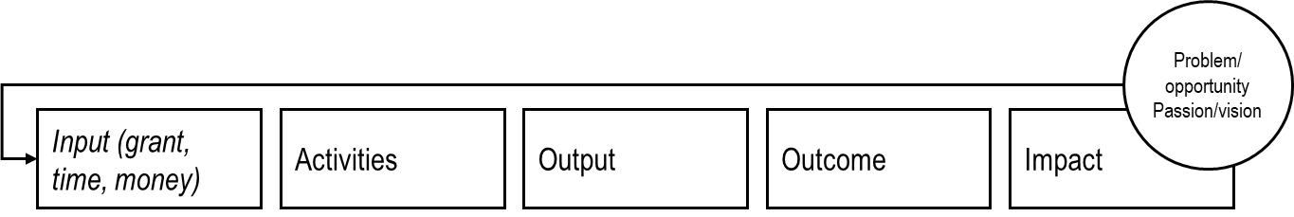

WRITING TIPS
Some useful writing tips for making your impact explicit, by University College Dublin

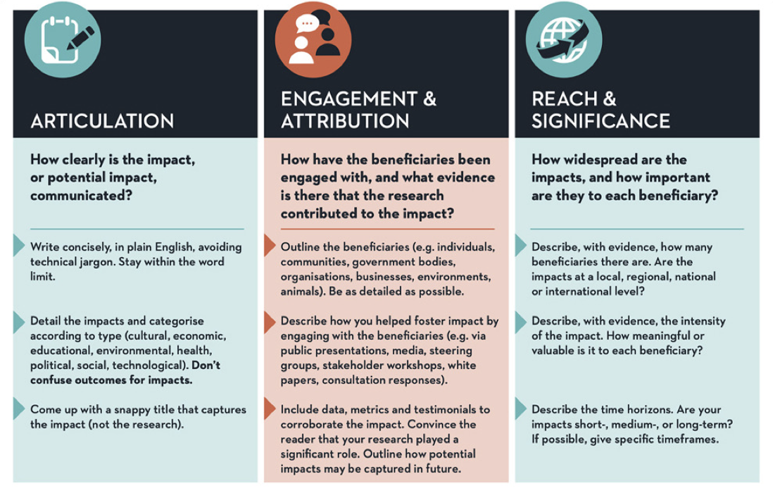

WRINTING YOUR IMPACT CASE

A. GENERAL INFORMATION

Author name(s):

Other contributors/partners:

Month and year of writing this case:

Title of the Impact Case:

B. INTENDED AUDIENCE FOR THIS IPMACT CASE

Who are you writing this impact case for? E.g., academic peers, your supervisor, potential partners from industry, a general non-academic audience, the local newspaper, …?

Keep this audience in mind while writing, so you can choose a matching set of vocabulary (e.g., disciplinary jargon or general terms) and tone.

C. SUMMARY OF THE IMPACT CASE

Approximately 150 words.

This section summarises your impact case. Write this section last.

You can summarise your case by explaining:
- What is/was your project/work about?
- What new knowledge and insights were generated?
- Which stakeholders were impacted by your efforts and how?

Focus on the change that has occurred (impact). Be bold and focused.

------------------------------------------------------------------------------------

D. WRITING AN IMPACT CASE USING THE IMPACT PATHWAY

Advice: max 1000 words.

The following question provide a guideline to define your impact case:

- Problem identification. What is the problem/opportunity addressed? And why is this relevant?
- Activities: what did you do? Describe enough of your topic so the (target) audience can place your work in context. Specify if this is the result of a single project or a combination of multiple projects with a shared goal.
  - What did you do? (interviews, prototyping, literature research, focus groups, modelling, lab work, field work, …, …)
  - What was your contribution to the project(s)? Were other partners/parties involved?
  - How long did the project run (until now)?
- Output. What new knowledge and insights were generated? How did you capture this? (In a tool, publication, set of standards, model, exposition, …,)
- Outcome. Who will use your work? (reference, build on, expand, shorten, translate to practice, …, …) What steps did/will you take to maximise the chance that your stakeholders are reached?
- Impact. Which stakeholders were impacted by your efforts and how? How did these stakeholders benefit from your work? What changed for them? Did things change for the better?
- Discuss evidence. How can you explicitly substantiate your impact and your efforts?

------------------------------------------------------------------------------------

E. REFERENCES GENERATED AS A RESULT OF THE RESEARCH (optional)

Include a maximum of 10 references (e.g., grants or follow-up grants, journal articles, book or book chapters, newspaper articles, given talks, …, ….). Specifically, this section should provide references to key outputs from the research described in the previous section, and evidence about the quality of the research. Preferably APA style.

You can use the Impact Indicator Inspiration Framework to get inspired by different possible measures that can underpin your story.

------------------------------------------------------------------------------------

