Schreurs, prof.dr. K.M.G. (Karlein)

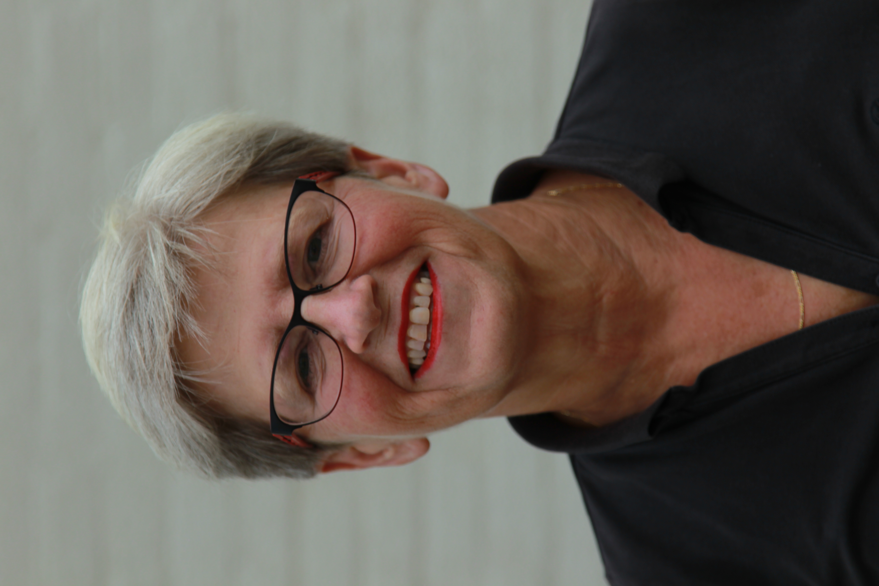 | Emeritus hoogleraar
 | Telefoon | : | 053 – 489 4470 (secretaresse)
 | e-mail | : | k.m.g.schreurs@utwente.nl

Expertise

My research and therapeutic work considered the assessment and treatment of chronic pain and fatigue. Central themes were the working mechanisms and effectiveness of Acceptance & Commitment Therapy (ACT). Chronic pain and fatigue cannot adequately be controlled by biomedical strategies. But a vital and fulfilling live is possible when patients stop aiming at controlling their complaints and focus their efforts on realising valuable life goals. ACT helps in this shift in perspective and fits well in the tradition of positive psychology. Chronic pain and fatigue have a high prevalence. Therefore, online treatments can reach many patients. However, knowledge of persuasive technology is needed in order to enhance treatment adherence. In addition to my work as a researcher, I worked as a senior therapist in ACT at the Roessingh Rehabilitation Centre.
Currently, I am a supervisor in Cognitive Behavioural Therapy (www.vgct.nl) and provide training in ACT to psychologists and other professionals (www.kmgschreurstrainingen.nl)

Publications

https://research.utwente.nl/en/persons/karlein-mg-schreurs

Veehof, M., Schreurs, K., Hulsbergen, M., Bohlmeijer, E. (2010). Leven met pijn. De kunst van het aanvaarden. Amsterdam: Boom.

Schreurs, K., Hulsbergen, M. (2011). Leven met pijn. Praktijk E-boek voor behandelaars. Amsterdam: Boom.

Verbunt, J.A., Swaan, J.L., Schiphorst Preuper H.R., Schreurs, K.M.G. (2019). Handboek Pijnrevalidatie. Voor de eerste, tweede- en derdelijns gezondheidszorg. Houten: Bohn Stafleu van Loghum.

