A Computational Fluid Dynamic Study of Glaucoma Drainage Devices
MSc Project Proposal

Background
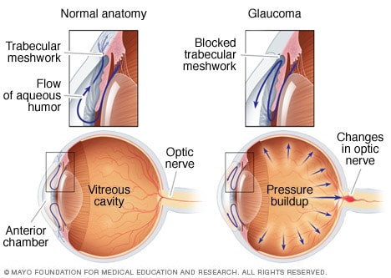
Glaucoma is a common ocular disease, especially among people of African descent, and may lead to irreversible blindness. Aqueous humour is a watery transparent fluid that nourishes the front segment of the eye and supports its structural integrity by creating intraocular pressure (IOP). A patient with an IOP higher than 22 mmHg can be suspected of developing glaucoma.
Glaucoma drainage devices (GDD’s) are often used to reduce IOP. Many GDD types exist, including the Xen 45 stent. For this GDD to be successful, a certain amount of flow is required for bleb formation. There may be enough flow to reduce IOP, but insufficient flow to keep the bleb formed. This appears to be the case with the Xen 45, which seems to have too small an internal diameter to allow enough flow for bleb formation, especially in black patients.

Research aim
Develop a 3D computational model of the human eye anterior segment that can be used in CFD simulations to accurately study the effects of glaucoma drainage device treatments.
The main objectives for this study will include:
- Developing a 3D geometrical model of the human eye anterior segment.
- Simulating GDD treatments and their effects on IOP and aqueous humour flow patterns.

Your profile
- Basic knowledge of fluid dynamics and computational fluid dynamics.
- Willingness to do self-study on eye anatomy, glaucoma, and glaucoma treatments.

Project details
- The work will be carried out at the University of Twente.
- The project will be co-supervised by A/Prof Wei Hua Ho from the University of the Witwatersrand in South Africa.
- The total duration will be 10 months.

Literature
Some links to literature on the panel method, spline theory, and constrained optimization:
- Laroche D, Nkrumah G, Ng C. Real-World Retrospective Consecutive Study of Ab Interno XEN 45 Gel Stent Implant with Mitomycin C in Black and Afro-Latino Patients with Glaucoma: 40% Required Secondary Glaucoma Surgery at 1 Year. Middle East Afr J Ophthalmol. 2020 Jan 29;26(4):229-234. doi: 10.4103/meajo.MEAJO_126_19. PMID: 32153335; PMCID: PMC7034147.
- Chen, X., Liang, Z., Yang, K., Lv, K., Ma, Y., Li, M., & Wu, H. (2022). The Outcomes of XEN Gel Stent Implantation: A Systematic Review and Meta-Analysis. Frontiers in Medicine. https://doi.org/10.3389/fmed.2022.804847
- N. Basson, F. Alimahomed, P. H. Geoghegan, S. E. Williams, and W. H. Ho, “An aqueous humour fluid dynamic study for normal and glaucomatous eye conditions,” in 2022 44th Annual International Conference of the IEEE Engineering in Medicine & Biology Society (EMBC), 2022, pp. 3963–3966.
- Production and flow of aqueous humour, https://entokey.com/production-and-flow-of-aqueous-humor/.

Contact information
For details and general info, please feel free to contact Nikki Basson:
E-mail n.basson@utwente.nl

