MSc thesis: Flexible operation of electrical driven salt evaporation plants

Introduction
Nobian is the leading producer of high purity salt for chemical applications in Europe. Nobian operates salt plants in Hengelo (NL), Delfzijl (NL) and Mariager (DK). Using brine from solution mining, the salt is crystallized by the evaporation of the water from the brine in these salt plants. The recrystallisation yields the high purity salt that is required by the end users, for example in the chemical industry. Purity directly has an impact on energy use and material efficiency downstream.
In the current salt plants, considerable part of the energy for the crystallisation is still supplied by steam. Nobian is in the process of electrification of its salt plants by the application of mechanical vapor recompression (MVR) technology, in these plants the energy for recrystallisation is supplied by electricity. The changing over to MVR technology can result in zero direct CO₂ emissions.
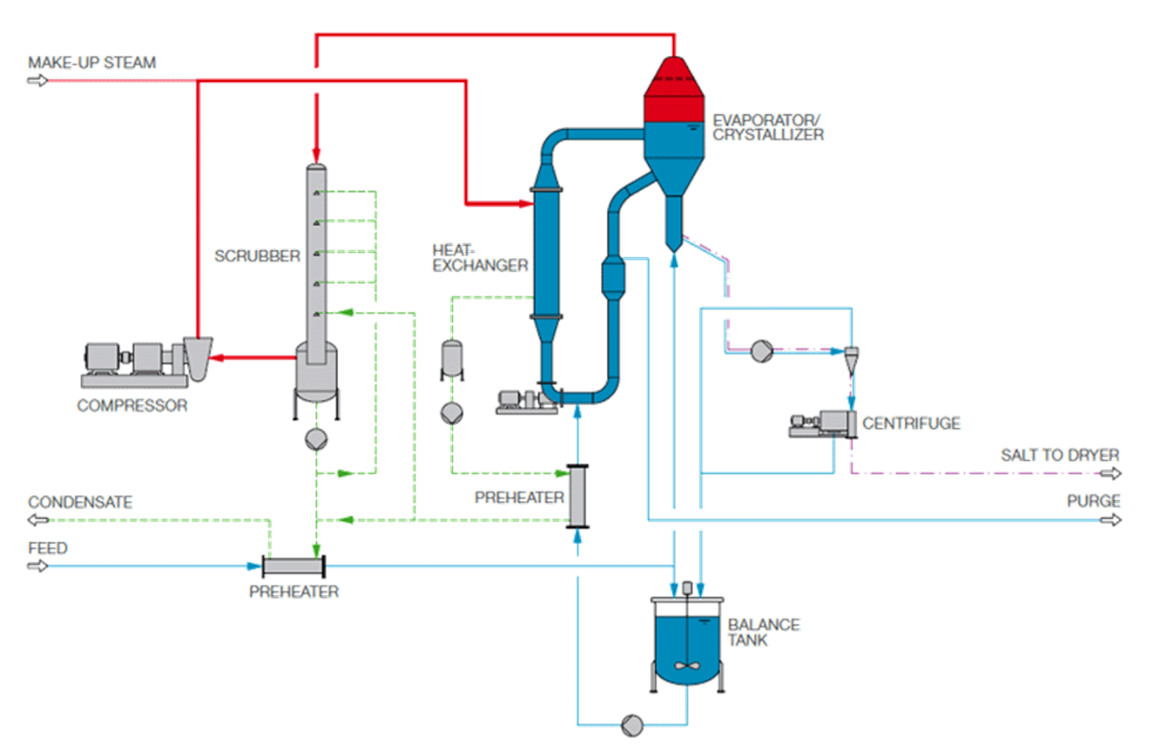
In the MVR installation, the compressor increases the pressure of the vapor that is generated by the flashing of the brine in the evaporator/crystallizer from typically 1 bar(a) to around 2 bar(a). This 2 bar(a) vapor/steam is used to preheat the brine (in the heat exchanger) before it is sent to the evaporator/crystallizer. In the evaporator/crystallizer the salt crystals are formed which are recovered as a salt suspension in brine. Part of the brine is recirculated over the heat exchanger. The suspension is sent to a centrifuge to remove the largest part of the water. The brine that enters the MVR has been pretreated in the upstream brine purification installation.

With the increasing share of renewables in electricity generation the demand of flexible electricity off take increases: There will be moments with low renewable electricity generation and thereby high prices or even limited availability of electricity.
Nobian has the intention to operate its (new) MVRs in a flexible way to be able to balance the fluctuations in electricity supply. Nobian has already some experience with its existing salt MVR in Delfzijl. Balancing the electricity grid enables increased application of renewable energy sources such as solar and wind.

MSc thesis study
The objective of this MSc thesis study is to analyze the potential flexibility of the MVR installation for salt crystallization. The compressor is by far the main electricity consumer in an MVR installation. The student should make a dynamic model of the MVR installation and the coupled unit operations (e.g. brine purification and centrifuges). The following layers can be distinguished in the model:
- The dynamic/part load performance of the compressor
- The impact of dynamic/part load operation of the compressor on the heat and mass balances of the MVR installation
- The impact of the dynamic/part load operation of the MVR installation on the brine purification and centrifuges
It is expected that at least the first two layers (compressor and MVR installation) will be included in the model. The third layer (impact on other unit operations) should be studied more qualitatively (e.g. time scale identification etc).
The model can be validated with the data from the flexible operation of the MVR in Delfzijl.
The MSc thesis study should result in design recommendations for flexible operation of the (new) MVR installations e.g. control recommendations, introduction of intermediate storage etc.

The candidate
We are looking for a motivated and smart student who has experience in the modeling of complex energy systems/chemical installations. You will work within the Nobian research team in Deventer but will also be in contact with the headquarters in Amersfoort and the plants in Delfzijl and Hengelo. So good project management and communication skills are important.

