Organization of the Master BME
The master Biomedical Engineering consists of three major components, these are the track related courses (60EC), the internship (15EC) and the master assignment (45EC) (fig. 1). Each track has 6 or 7 obligatory courses which you complement with at least 3 track specific (blue) electives. To complete the course list to 60 EC, you add a maximum of 3 elective (yellow) courses. For each of these components are standard procedures in place which you need to follow. Please note this is a summary from where no rights can be obtained, and all official rules are stated in the EER and Rules of the Examination Board

Specifying interests
During the first quartile of the BME Master programme, you have to sort out your interests and abilities in order to determine at which research group you want to do your master’s assignment and we challenge you to think backwards (see figure 2). This is important because some research groups require you to follow specific elective courses. As soon as you know at which research group you might want to do your master’s assignment, you contact the professor of that research group to discuss the elective courses you have to do in order to start the master’s assignment at that group. At the end of your first quartile, your course list has to be approved by the Board of Examiners.

Note: for following or choosing courses for the 1st quartile: choose courses of your interest and/or appeals to you. Most likely, this fits in the bigger picture of your master plans. You can register via Osiris and skip the error of courses not being part of your exam programme.

Course List
While composing your course list, the plans for the master's assignment are still raw and without any details. You know the type of subjects and possibilities you are capable of after completing the courses. Most research groups ask 1 or 2 courses outside the mandatory courses. With this, you are able to draw a course list with more options for graduation. The course list therefore is adjusted to your possible plans. This has multiple advantages:
- Advantage 1: You and your supervisor(s) are assured of the right knowledge and skills at the start of your assignment.
- Advantage 2: When you like a course, recommended for your graduation plans, you know you are on the right track. You can start specifying your individual master assignment because you have more and more information on the subject.
- Advantage 3: If you dislike a course, recommended for your graduation plans, or if you are positively surprised by a completely different course, you can alter your plans much earlier than after the start of your assignment.

Internship
During the third quartile of the first year it is necessary to make arrangements (e.g. visa/scholarship etc.) for the internship. These can consume a lot of time so it’s important to start early on, and we advise to start the orientation approximately 6 months before you would like to start. You are allowed to start your internship when you have at least 30 EC of courses completed. The start and end date are in consultation with your supervisors, and do not necessarily coincide with the quartile boundaries.

The internship and master's assignment cannot be performed at the same department/institute/project. They have to be separate projects.

Master’s Assignment
When you are almost finished with the courses, you start making your master's assignment plans more detailed and specified together with your supervisor. After you have completed the internship and at least 50EC of the courses you may start with your master assignment. All courses need to be completed before your master colloquium. The start and end date are in consultation with your supervisors, and do not necessarily coincide with the quartile boundaries.

The summary of the procedures regarding the course list, internship and master’s assignment can be found on the next pages.
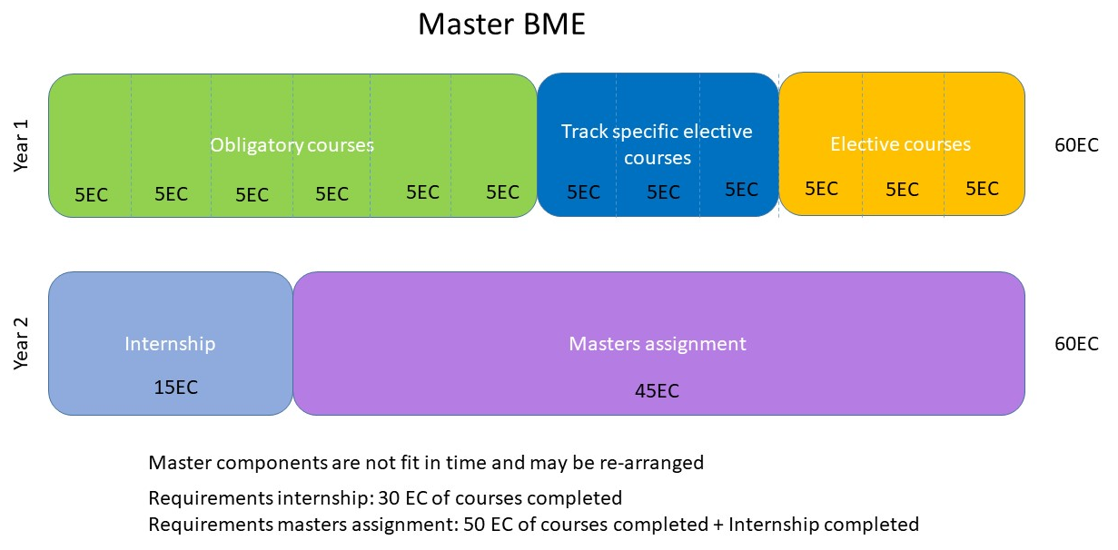
Figure 1: Overview Master BME components
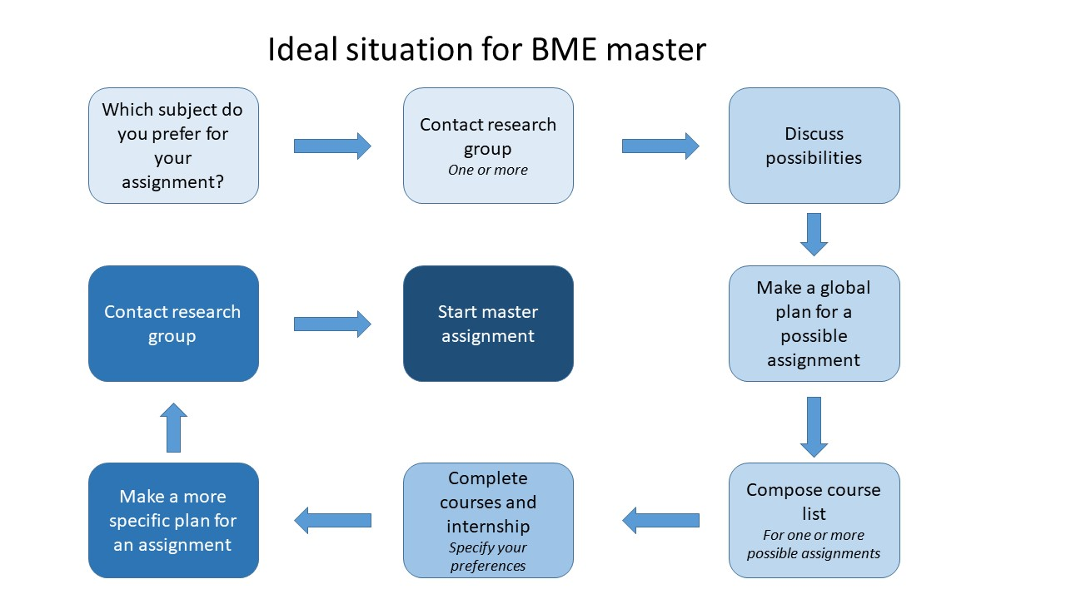
Figure 2: Ideal plan for arranging the BME master, to be started during the first quartile as master student

Procedure for choosing a course list
  - (Rules Examination Board Article 12, OER M-BME Article 7 and 8)

1. A course list will be composed in consultation with the professor or associate professor of the chair where the student wishes to graduate. This course list must be approved by this professor or associate professor.

2. This course list will be presented to the examination board for their approval as soon as possible, but at the latest at the end of the quartile in which the master started.

3. When a Capita Selecta is chosen, the content must be approved by the examination board. The student must submit the Capita Selecta form from Canvas with the application. It is possible to submit the list of subjects first, and to specify the Capita Selecta later. However, the student needs to have approval for the content before starting the Capita Selecta. The student may be supervised in the Capita Selecta by a professor/UHD or UD.

4. To include subjects in the course list that are not part of the standard BME curriculum (see course supplement Article 8 and/or the website) explicit permission from the examination board is required. The application for courses that are not part of the regular BME curriculum should include the course description, the learning objectives and a motivation for following the chosen courses. The same applies for subjects taken at universities abroad.

5. If students wish to make changes to their course lists and/or graduation specialisation after further consideration, a new course list must be presented to the examination board for their approval. This request accompanied by a brief explanation as to why.

6. Students will be informed in writing of the examination board’s approval or rejection by the BOZ staff member, where possible, within two weeks after receiving the course list (official holidays not included). Course lists with not already pre-approved electives and double masters will receive an approval or rejection within two weeks after the first examination board meeting.

Procedure for internships
Q3: start arranging internship

  - (Rules Examination Board Article 13, OER M-BME Article 12)

The main purpose of an internship is to teach the students to function in a practical situation at an upcoming MSc level, in order to apply and further enhance the knowledge and skills they have acquired. In this way, the student can orientate himself to the professional practice and discovers possible interesting jobs for the future. The main purpose of the internship is to develop academic, vocational and social skills. You can start your internship after completing at least 30 EC of courses.

1. For the entire procedure surrounding the internship, students are referred to the Canvas page 'Internships TNW’ and the internship policy of the BME study programme. It is recommended to plan a meeting with the internship coordinator when you start orienting for your internship.

2. All internships are coordinated by the Internship Office of the Faculty of Science and Technology. Students should register their internships in Mobility Online before they start.

3. The contents of the internship must be approved by a UD, UHD or postdoc of the BME programme in advance. They will also act as internship supervisor on behalf of the UT.

4. The internship will be assessed by a UD, UHD or postdoc of the BME programme, in consultation with the supervisor at the student’s internship placement through the internship assessment form.

5. The internship coordinator and the education coordinator give approval for the start of the internship. If there is doubt about the BME content within the internship, the assignment will still be submitted to the examination board.

Procedure for master assignment and graduation
Q4: start composing master assignment according to the procedure and article 14

  - (Rules Examination Board Article 14 and 16, OER M-BME Article 10)
You can start with your assignment when you have at least 50 EC of courses and a completed internship.

1. The objective of the assignment is to learn to carry out a design and/or research assignment of a certain size and complexity independently.

2. The registration in Mobility Online of the master's assignment must be officially approved before the start of the assignment, up to a maximum of 2 weeks after the start.

3. The master's assignment may be carried out at one of the biomedical chairs of the UT or at an external client via and under supervision of a biomedical chair.

4. The Master's assignment, if carried out at one of the biomedical chairs, shall be designed in consultation with the graduating professor.

5. The Master's programme, if carried out by an external client, will be designed in consultation with one of the professors involved in the BMT/BME programme and the day-to-day supervisor of the external client.

6. In special cases it is possible to carry out the master assignment externally (outside the UT), provided the assignment falls under the responsibility of one of the professors or associate professors involved in the BME programme. Given the differing nature and objectives of the final master’s assignment and the internship, it is important that the two differ sufficiently in terms of content. An external final master’s assignment requires the explicit approval of the examination board regarding content, supervision and graduation committee before the start of the internship.
Around the start: Register your assignment
7. In the case of an external master's assignment, the external client where the assignment is to be carried out must collaborate with the department of the BMT/BME study programme or there must be agreements between the expertise of the external client and the department of the BMT/BME study programme.

8. Procedures regarding the master's assignment can be found on the Canvas page of the master's assignment.

9. The composition of the final master’s assignment committee and the nature of the assignment must be uploaded in Mobility Online for approval by the examination board. This approval must be obtained within two weeks of the start of the final master assignment.

10. The student and the chairperson of the final master’s assignment committee will be informed in writing of the examination board’s approval or rejection of the final master assignment. They must be informed, if possible, within two weeks of receiving the registration in Mobility Online, excluding the holidays listed in the university’s timetables.

11. In part to aid assessment of the final master’s assignment, students will present the final master’s assignment committee with a final report. The assessment criteria can be found on the Canvas page of the master's assignment. The members of the final master assignment committee must have received this report at least one week prior to the master colloquium. Students will defend their report to the final master’s assignment committee via a master’s colloquium. This colloquium is open to the public.
Nearing the end: Start the final steps with the Green light meeting and planning the colloquium

12. The student will defend their report to the final master’s assignment committee via a colloquium. This colloquium is open to the public. The colloquium can only be scheduled if, during the green light meeting, the committee is confident that the colloquium will be successfully completed and the report grade will be at least 5.5. The green light meeting is a meeting with the entire committee to discuss whether each of the aspects to be assessed are already sufficient at this stage, or which points for improvement need to be implemented in order to achieve a pass. If the entire committee cannot be present at this meeting, the student will ensure that feedback is obtained from all members. The colloquium can only be requested if the entire committee expects the student to score sufficiently on content, implementation and reporting by the intended graduation date.

13. The colloquium may only be scheduled once all other master's examination components have been completed satisfactorily.

14. At least one month prior to the scheduled colloquium, the student must submit an application form for the exam, signed by the chair of the final master’s assignment committee, to the Centre for Educational Support (BOZ) of the Faculty of Science and Technology (contact details on the form). This form can only be submitted if both the student and the chairperson of the final master’s assignment committee expect the student to pass the exam (green light meeting). This exam application is approved per mandate by the examination board.

15. The final master’s assignment will be assessed with a single grade. After the colloquium, the chairperson of the graduation committee will give an oral explanation of the grade, including discussion of the various aspects of the components the make up the final grade.

16. After the colloquium, the student will be given their master’s certificate. An overview of the grades received for all exam parts will follow within one month. Any extra-curricular subjects they may have completed will be listed separately in the supplement.

Appendix

Article 16 Final assignment committee (Rules Examination Board)
1. For the purpose of supervising and assessing the final master’s assignments of the master’s programme, a final master’s assignment committee will be appointed. This appointment will be handled in joint consultation between the chairperson of the master’s assignment committee and the student, where the BME field is sufficiently represented and the committee has experience in supervising BME graduates. The committee is then submitted to the examination board for approval.

  - 2. The final master assignment committee will consist of a minimum of three members. The committee will include at least:
  - The professor or associate professor under whom the assignment will be completed, insofar as they are not the everyday supervisor of the assignment. They are also chair of the committee. The chair must be authorised to assess BME examinations have experience in supervising BME graduates.
  - The everyday supervisor of the student (professor/associate prof./assistant prof./PhD student); the everyday supervisor must be a member of the permanent or temporary scientific staff of the above-mentioned chair;
  - One member of the scientific staff (professor/associate professor/assistant professor/ PhD student with supervisory experience/ Junior of senior researcher) of a different research chair than the one the final assignment will be completed in (the so-called external member). The external member may also be an external expert with a PhD if the student graduates within the UT with collaborations outside the UT;
  - If the everyday supervisor and the professor/senior lecturer are the same person, an extra member from the same chair must be added to the committee. If this is not possible, an additional member of the scientific staff of a different chair must be added to the committee.

3. If the final master’s assignment is completed with an external (non-UT) organisation, a representative of this organisation must be added to the final master’s assignment committee in an advisory capacity. In this case, in addition to the chairman, at least two UT employees must be included as committee members, so that the UT is sufficiently represented when graduating outside the UT.

4. The requirements for the final master's assignment committee mentioned are leading, each application for a final master's assignment committee is assessed individually by the examination board. If the student wishes to deviate from the requirements, the student can submit a request including justification to that effect to the examination board, asking for explicit approval.

  - Check the most actual version on the website: https://www.utwente.nl/en/bme/formsandregulations/

Application form for Master’s course list

Please submit this form to BOZ-TNW-BME (boz-bme@utwente.nl) before the end of the 1st quartile as master student..
Student name: |  | MSc track:  X before the track |  | Bioengineering Technologies
Student number: | S |  |  | Biorobotics
 |  |  |  | Imaging & in Vitro Diagnostics
 |  |  |  | Medical Device Design
 |  |  |  | Physiological Signals and Systems
Research group:
Faculty:
Professor:

Course list (at least 60 EC)
Code | Course name | EC | Planned in quarter / year (e.g. Q1/23-24)
Compulsory courses (30 EC)
Track Electives (Minimum 15 EC)
Preapproved elective courses
Other courses (needs motivation, maximum 15EC)
Internship (15EC, also mandatory for double master students)
Master assignment (45EC)

Motivation in case of other electives:

Student signature: ------------------------------------ Professor signature: -------------------------------------------
Date: ------------------------------------ Date: -------------------------------------------Confirmation of course requirements by the BME Board of Examiners.
Signature: ------------------------------------ Date: -------------------------------------------
  - Check the most actual version on the website: https://www.utwente.nl/en/bme/formsandregulations/

Application form for Master’s exam and arrangements for colloquium
Please submit this form to BOZ -BME at least four weeks before planned colloquium.

Student
Name: Student number:
Telephone:
MSc track:

Research group
Name: Faculty:
Chairman MSc Assignment Committee:
Supervisor
Member other Research group:
External Advisor

Colloquium of the MSc assignment
Title:
Title Thesis (if different than title colloquium) :
Date:
Time:
Number of attendees: (estimated)
Location:

Requirements to apply for the master’s exam
Hereby, student and chairman of Msc Assignment Committee confirm that student meets all requirements to apply for the final MSc exam.

Signature:
Student: Chairman MSc Assignment Committee:
----------------------------------------------------- -----------------------------------------------------

Date:--------------------------------------------- Date:---------------------------------------------
____________________________________________________________________________

Confirmation of exam requirements by the Board of Examiners of BME.
Signature:

------------------------------------------ Date:---------------------------------------------

For an overview of compulsory/elective courses, see the curriculum on the BME website at https://www.utwente.nl/en/bme/curriculumbme/
If location is arranged via BOZ-TNW and the ”Reserveringsbureau’’ colloquium is only possible on official lecture hours!
Or representative

