3D Printed MEMS Micro Mirrors
Micro mirrors play a pivotal role in technologies ranging from LiDAR and fiber optic switches to medical devices such as endoscopes. With the advent of 3D printing, MEMS (Micro-Electro-Mechanical Systems) micro mirrors can now be fabricated with greater design flexibility than traditional micromachining methods, offering significant advantages for a wide array of applications.
This master's thesis project aims to design, fabricate, and evaluate a 3D printed MEMS micro mirror that can be seamlessly integrated with other photonic components. Utilizing the Nanoscribe 3D printer within the MESA+ cleanroom facility, the student will embark on a comprehensive process. This includes conceptualizing the actuation mechanism and deflection capabilities of the micro mirror, validating the design through simulation, fabricating the prototype with 3D printing technology, and finally, conducting a characterization of the micro mirror's performance.
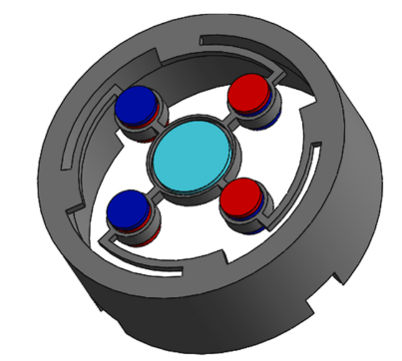 | 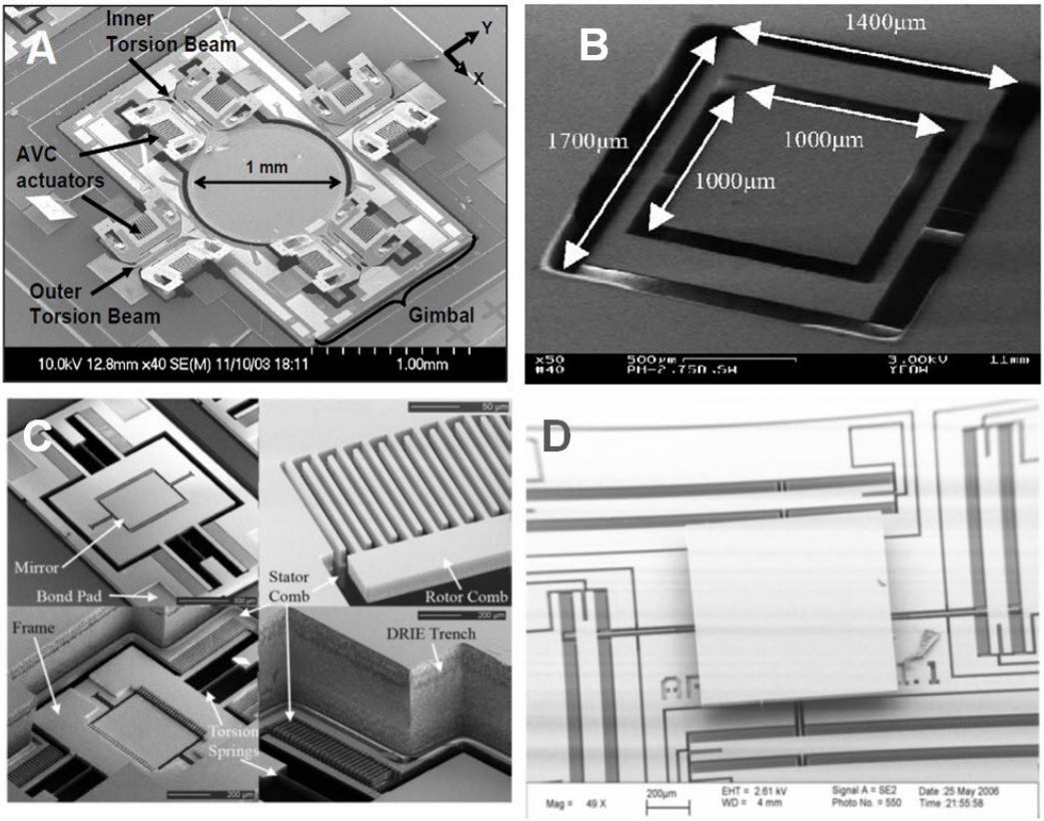
Figure 1. Seo et.al. [1] proposed a 3D printed micro mirror. The red and blue pillars are electromagnetic actuators. The blue pillar is the reflective mirror. The diameter of the scanner is 24 mm. | Figure 2. Eakkachai et.al. [2] reviewed various micromachined micro mirrors. Micromachined mirrors presented in this review often involves more complex fabrication processes compared to 3D printing methods.

Reverences
[1] J. Seo, J.-Y. Hwang, and C.-H. Ji, “Electromagnetic 2D scanning micromirror fabricated with 3D printed polymer parts for LiDAR applications,” Sensors Actuators A Phys., vol. 348, no. PA, p. 113997, Dec. 2022, doi: 10.1016/j.sna.2022.113997.
[2] E. Pengwang, K. Rabenorosoa, M. Rakotondrabe, and N. Andreff, “Scanning Micromirror Platform Based on MEMS Technology for Medical Application,” Micromachines, vol. 7, no. 2, p. 24, Feb. 2016, doi: 10.3390/mi7020024.

