Project Title: Design an Angled MMI (Multi-Mode Interferometer)
Project Description:
Are you fascinated by the world of photonics and optical devices? Are you passionate about cutting-edge technology and innovative design? If so, our student project offers an exciting opportunity to explore the field of photonic engineering by investigating the design of angled multimode interferometers (MMIs).
Project Overview:
Multi-Mode Interferometers (MMIs) are fundamental components in the field of integrated optics and photonics. They play a crucial role in various applications, including optical communication, sensing, and signal processing. In this project, you will embark on the journey of designing an angled MMI, a specialized MMI configuration with unique properties and advantages.
Key Objectives:
- Conceptualization: Begin by gaining a deep understanding of MMI principles and exploring the specific challenges and benefits associated with angled MMIs.
- Design and Simulation: Utilize simulation tools and software (Lumerical) to design an angled MMI tailored to your project's objectives. Consider parameters such as waveguide dimensions, angle of incidence, and material properties to optimize the device's performance.
- Fabrication Considerations (optional based on progress): Placement in MPW run will be considered based on the design completion time.
- Characterization (optional based on progress): Characterize the performance of the angled MMI. This may involve optical testing, measurements of insertion loss.
- Optimization (optional based on progress): Continuously refine and optimize the MMI design based on simulation and characterization results to achieve desired performance metrics.
Expected Outcomes:
- Gain hands-on experience in designing, simulating, and potentially characterizing advanced photonic devices.
- Develop a deep understanding of the principles and applications of MMIs in integrated optics.
- Acquire valuable skills in using optical simulation software (Lumerical) and laboratory equipment.
- Present your findings and results in a comprehensive report or presentation.
Prerequisites:
- Basic knowledge of optics and photonics principles.
- Familiarity with simulation software (e.g., COMSOL, Lumerical, or equivalent) is a plus but not mandatory.
Duration:
The project can be adapted to both master's and bachelor's level assignments, with the scope adjusted accordingly. The duration may vary depending on the specific objectives and complexity of the design.
Join us in this exciting journey to push the boundaries of photonic engineering by designing a cutting-edge Angled MMI. This project offers an excellent opportunity to explore the world of integrated optics and leave your mark on the field of photonics.

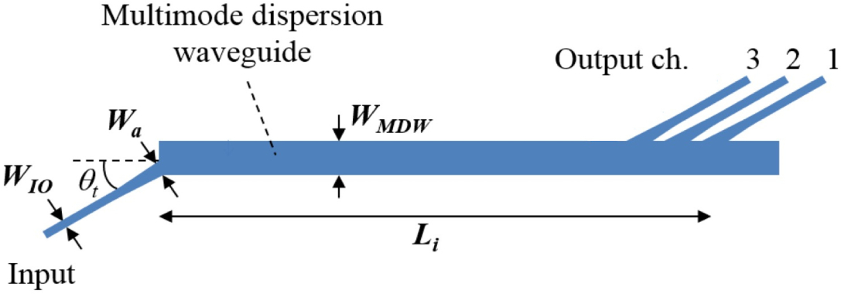
[1] Domínguez Bucio, T., Khokhar, A. Z., Mashanovich, G. Z., Gardes, F. Y., Wang, L., Bogaerts, W., Dumon, P., Selvaraja, S. K., Teng, J., Pathak, S., Han, X., Wang, J., Jian, X., Zhao, M., Baets, R., Morthier, G., Lee, J. M., Kim, D. J., Ahn, H., … Zhang, H. (2017). Athermal silicon nitride angled MMI wavelength division (de)multiplexers for the near-infrared. Optics Express, Vol. 25, Issue 22, Pp. 27310-27320, 25(22), 27310–27320. https://doi.org/10.1364/OE.25.027310

