Grating Coupler for UV in Aluminum Oxide waveguides

A grating coupler is an optical device used to couple light in a waveguide. The guided-mode in an optical waveguide can be excited and simultaneously extracted by the introduction of a phase-matching element (the grating) between the waveguide and the optical fiber. The grating is built directly on the waveguide edge. Off-resonance light incident on the grating won’t be coupled into the waveguide. For specific combinations of incident angles and light frequency, there is resonance, allowing the grating to couple light into a guided mode of the waveguide. A schematic of the setup is shown in Figure 1.
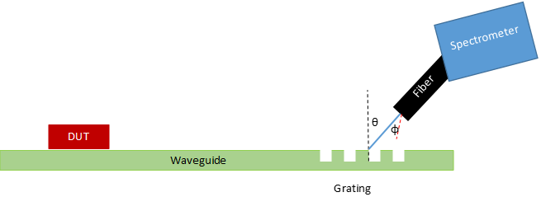
Figure 1 The light beam from a single-mode fiber is coupled into the waveguide by a grating to measure the spectral response of the Device Under Test (DUT) connected to the waveguide

The grating coupler equation is given by:
m2π=Λk0(neff−nisin(θi))
From which we can get the resonance wavelegth equation as follows:
λ=Λ(neff−nisin(θi))

Master Assingment

The project consists of designing the grating coupler using Ansys Lumerical software and building the optical measurement setup for waveguide characterization. The propagation and coupling loss are calculated using the Cutback method: waveguide with different length are measured and the loss measurements are fitted with a linear function. The coupling loss is given by the intersection of the line with the y-axis, whereas the propagation loss is read from the angular coefficient of the line.

