Validity of Imbert-Fick Law in the measurement of intraocular pressure
MSc Project Proposal

Background
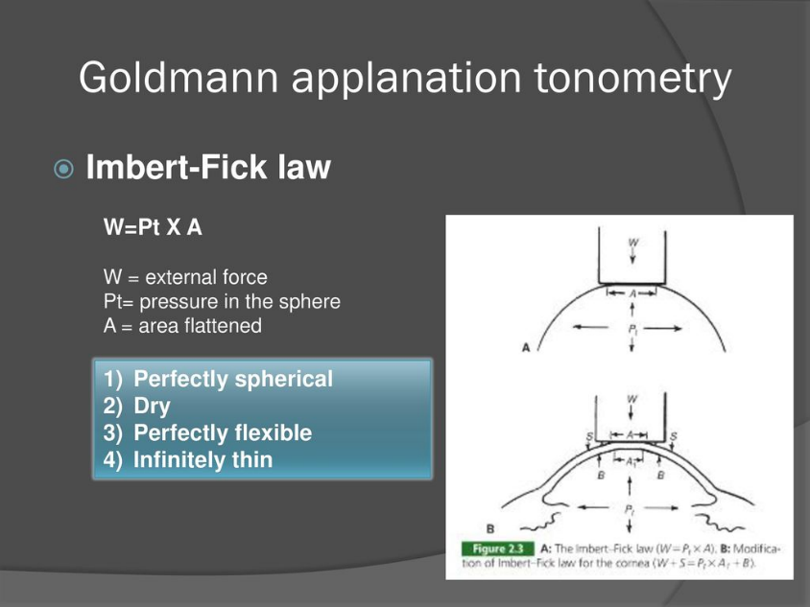
Intraocular pressure (IOP) measurement is an important parameter in the detection and monitoring of glaucoma. Measurement of IOP is assumed to be accurate, with the Goldmann applanation tonometer becoming the international gold standard for IOP measurement. It is also generally assumed that Goldmann tonometry is equally accurate in all eyes and is not influenced by ocular parameters such as corneal thickness and radius of curvature. However, this assumption is increasingly being called into question. Measurement of IOP by applanation tonometry is based on the Imbert-Fick law, which states that the force required to flatten or applanate a sphere (W) is equal to the product of the pressure inside the sphere (P) and the area applanated (A): W=P×A.

Research aim
Study the validity of the Imbert-Fick Law for various corneal parameters using an experimental setup and computational model.
The main objectives for this study will include:
- Develop a computational model of a pressurised corneal structure with varying cornea thickness and curvature.
- Use finite element methods to compare tonometry simulation results with a mathematical model of the Imbert-Fick law to determine its validity.

Your profile
- Basic knowledge of mechanics and ANSYS FEM.
- Willingness to do self-study on eye anatomy, glaucoma, and IOP measurement devices.

Project details
- The work will be carried out at the University of Twente.
- The project will be co-supervised by A/Prof Wei Hua Ho from the University of the Witwatersrand in South Africa.
- The total duration will be 10 months.

Literature
Some links to literature on the panel method, spline theory, and constrained optimization:
- Goldmann Applanation Tonometer, https://www.sciencedirect.com/topics/nursing-and-health-professions/goldmann-applanation-tonometer.
- McCafferty, S., Levine, J., Schwiegerling, J. et al. Goldmann applanation tonometry error relative to true intracameral intraocular pressure in vitro and in vivo. BMC Ophthalmol 17, 215 (2017). https://doi.org/10.1186/s12886-017-0608-y.
- Asejczyk-Widlicka M, Srodka W. Finite element simulation of Goldmann tonometry after refractive surgery. Clin Biomech (Bristol, Avon). 2020 Jan;71:24-28. doi: 10.1016/j.clinbiomech.2019.09.007. Epub 2019 Oct 5. PMID: 31677547.
Contact information
For details and general info please feel free to contact Nikki Basson:
E-mail n.basson@utwente.nl

