Developing High-Quality Edge Couplers for Integrated Photonics
Achieving low-loss optical coupling in integrated photonics is a significant challenge. Edge coupling technology, which allows light to exit the chip at its edge, parallel to the chip surface, offers a promising solution. However, the effectiveness of edge coupling largely hinges on the quality of the optical facets. Normally, these high-quality facets are obtained through a polishing process after the wafers are diced. This method, while effective, is limited to the edges of flat chips and additionally increases the production costs due to the extra polishing step.
The focus of this master's thesis project is to innovate a fabrication method that ensures high-quality facets suitable for edge coupling, without relying on traditional polishing. The ideal approach will only encompass micro machining techniques, such as etching and deposition, to streamline the fabrication process.
As a master's student involved in this project, you will engage in various stages of research. This includes designing the fabrication process, conducting and fine-tuning critical etching steps, and carrying out thorough inspections using Scanning Electron Microscopy (SEM) and optical characterization tests.
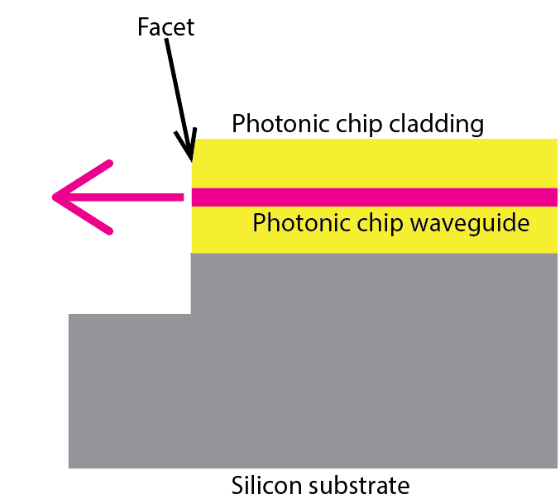 | 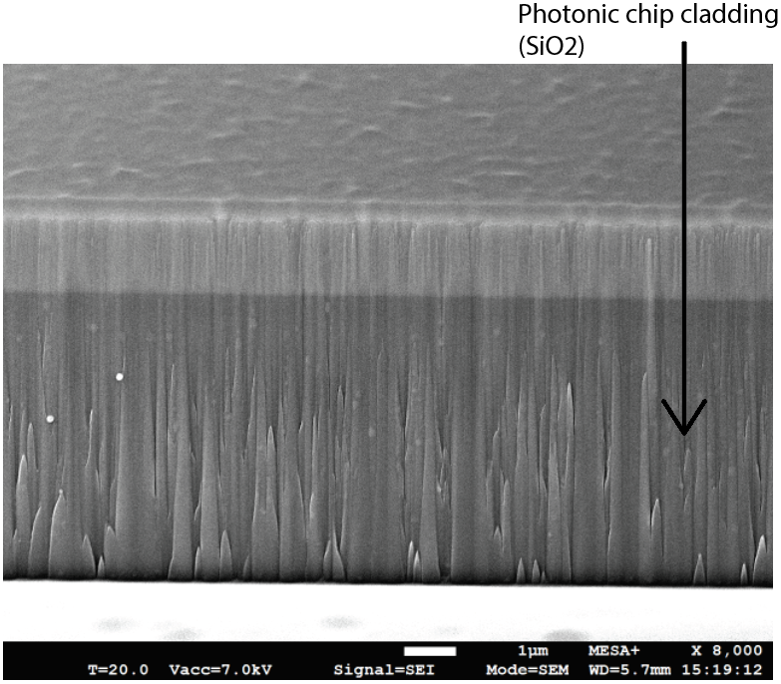
Figure 1. Cross section of a edge coupling structure. The light exit the chip from the facet. Note the non-polishable facet due to the stair-step feature under the fiber. | Figure 2. SEM Image of the Facet from Figure 1. Initial trials reveal vertical spikes on the facet, causing light scatter and reduced coupling efficiency."

