Introduction
Carbon Dioxide (CO₂) is the most prevalent greenhouse gas, primarily generated through the combustion of fossil fuels in industries such as power generation, cement production, and chemical manufacturing. The growing concerns over climate change have led to the development of various CO₂ capture technologies. Among these, adsorption-based CO₂ capture stands out for its potential efficiency and adaptability. Direct Air Capture (DAC), is an important technology that allows for the removal of carbon dioxide from the atmosphere. However, the overall effectiveness of these systems is highly dependent on the reactor configuration and the method used for regeneration. Advanced reactor designs, optimized operating conditions, and effective regeneration strategies are key to maximizing the CO₂ absorption capacity while minimizing the energy requirements and operational costs. The need for enhanced CO₂ capture efficiency has spurred research into different reactor configurations, such as fixed-bed, fluidized-bed, and membrane reactors, each offering unique advantages based on specific operating conditions. Moreover, the regeneration of CO₂ sorbents, which allows for their reuse in continuous cycles, is another area of active research. Various regeneration techniques, such as thermal, pressure-swing, and chemical regeneration, offer different trade-offs between energy efficiency and process sustainability. | 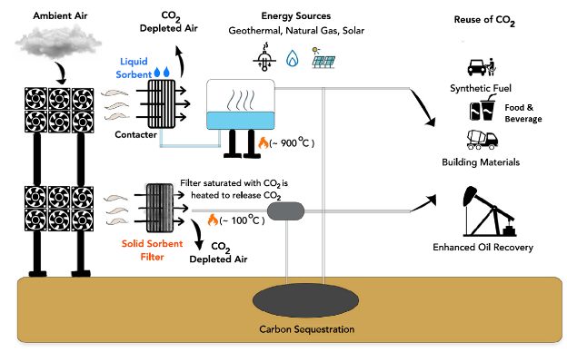
 | Fig. 1 Schematic of Direct Air Captures (DAC) systems
 | 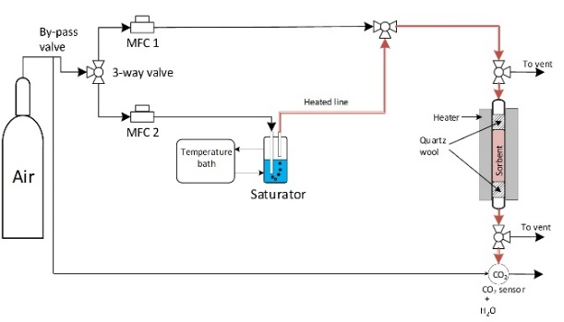
 | Fig. 2 Experimental setup for the cyclic DAC experiments
Problem Statement
1. Standardization Needs: There is an urgent need to standardize the assumptions used in thermodynamic and economic assessments across different reactor configurations and regeneration modes.
2. Simulation Gaps: Current research often lacks comprehensive simulation studies that compare and optimize various reactor configurations, such as fixed bed, multistage fluidized bed, moving bed, and structured reactors.
3. Heat Integration Challenges: Understanding the extent of heat recovery and its integration in different configurations is crucial for improving overall system efficiency but is currently underexplored.

Research Objectives
1. Simulation of Reactor Configurations: Develop detailed simulations for fixed bed, or (multistage fluidized bed, moving bed, and structured reactors), evaluating their performance under various operating conditions. (e.g., Aspen Plus, COMSOL Multiphysics, or MATLAB)
3. Optimization of Reactor Designs: Apply optimization algorithms to refine the design and operation of the reactors, aiming to maximize CO₂ capture efficiency while minimizing energy consumption. ( genetic algorithms, particle swarm optimization, gradient-based methods)
3. Validation and Sensitivity Analysis: Validate simulation results using experimental data from literature or pilot studies and conduct sensitivity analysis to identify key parameters influencing system performance.

Your background
We are looking for excellent master students with a Mechanical Engineering or Sustainable Energy Technology background with a willingness to learn COMSOL Multiphysics/Matlab.

Contact
Dr. ir. A.K. Singh (a.k.singh@utwente.nl)
Dr. Abolfazl Nematpourkeshteli (a.nematpourkeshteli@utwente.nl)

