Measuring the performance of a Mach-Zehnder interferometer

Background
Integrated optics can be used to fabricate compact and highly sensitive sensing chips. Microring resonators (MRR) have emerged as a preferred choice for sensing applications. However, MRR-based sensors rely on high resolution and expensive tunable laser sources, thereby increasing the costs of such a system and limiting its applicability. An alternative is a Mach-Zehnder interferometer (MZI). An MZI-based system can operate at a single wavelength, and when a coherent phase read out is applied, it can achieve lower detection limits [1]. Its operation at a single wavelength makes it more amenable to integrate all components onto a single chip. This would be a first major step towards sensors that can, for example, measure blood parameters in vivo in animals.
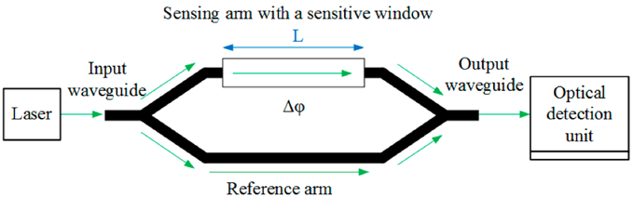  (a) | 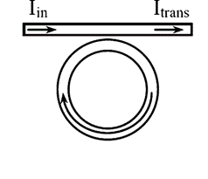  (b)
Figure 1) Schematic sketch of (a) a Mach-Zehnder Interferometer and (b) a microring resonator [2,3]

Project
The assignment focuses on measuring in the optics lab and analysing the results. Several Mach-Zehnder Interferometers have been designed and now its time to characterize its components and test its sensing qualities. The MZI consists of a beam splitter and a 120∘ downconverter, these individual components will first be characterized. Thereafter the total device can be characterized by flowing water with different salt concentrations over the sensor. If the time allows, also microring resonators can be measured, and the performances of the MZI and MRR can be compared.

Contact
If you are interested in this project, or if you are looking for more information about possible (other) assignments, feel free to contact:
Bjorn Jongebloed (b.jongebloed@utwente.nl)
Lantian Chang (l.chang@utwente.nl)
Sonia García Blanco (s.m.garciablanco@utwente.nl)

References
[1] Íñigo Molina-Fernández, Jonas Leuermann, Alejandro Ortega-Moñux, J. Gonzalo Wangüemert-Pérez, and Robert Halir, 2019, "Fundamental limit of detection of photonic biosensors with coherent phase read-out," Opt. Express 27, 12616-12629. https://doi.org/10.1364/OE.27.012616
[2] Yuan, Dengpeng, Ying Dong, Yujin Liu, and Tianjian Li. 2015. "Mach-Zehnder Interferometer Biochemical Sensor Based on Silicon-on-Insulator Rib Waveguide with Large Cross Section", Sensors 15, no. 9: 21500-21517. https://doi.org/10.3390/s150921500
[3] Chao, Chung-Yen & Fung, W. & Guo, Lingjie, 2006, “Polymer microring resonators for Biochemical Sensing Applications”, Selected Topics in Quantum Electronics, IEEE Journal of. 12. 134 - 142. https://doi.org/10.1109/JSTQE.2005.862945

