# Active integrated photonic sensors

## Background

For a long time, electronic circuits have dominated the field of integrated circuitry. The possibilities of

semiconductor technologies are widely studied and applied. However, an alternative integrated circuit uses glass waveguides that guide light from one place to another. Such a system consisting of waveguides is called a photonic integrated circuit (PIC).

One of the materials that can be used to create waveguides is aluminium oxide, Al2O3. This particular

material is of great interest in integrated optics because it has a large transparency window. Consequently, Al2O3 waveguides can be designed to guide light ranging from ultraviolet to mid-infrared. The large transparency window makes it a versatile material platform, allowing for many different applications. Furthermore, the Al2O3 waveguides have low propagation losses and can be doped with rare-earth ions [1]. Therefore, this material can be utilised for, for instance, on-chip lasers. This project focuses on a different application, however. The area of interest targeted with this project are integrated photonic sensors.

Withing this project, the high rare-earth ion solubility of Al2O3 is exploited to create highly sensitive biosensors. This idea has been explored in the past, using a specific combination of host material and rare earth ion [2]. In recent work, we have shown that another rare earth ion shows possible higher gain at a similar wavelength [3, 4]. Therefore, we want to try the ideas of active sensing with this new rare earth, Neodymium.

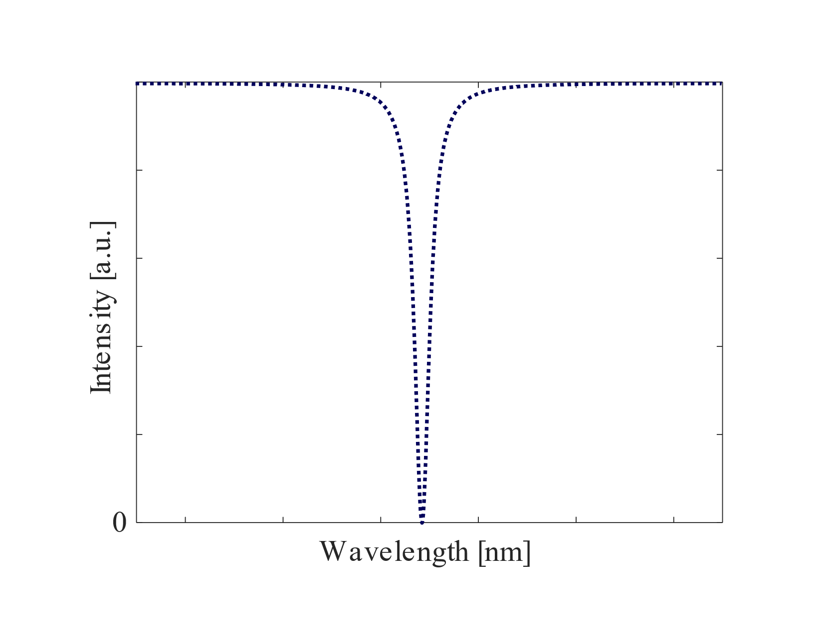

*Figure 1. Simple configuration of a (passive) ring resonator sensor. Upon binding to biomarker molecules, the transmission spectrum changes.*

## Project

A set of Al2O3:Nd3+ layers have been deposited with various Nd3+-concentrations. The goal of the project is to turn these doped layers into functional devices that can be used for biosensing. For this project, different approaches for sensing can be used, that have been proven to give sensitive sensors in passive waveguide platform. However, the idea is to now take advantage of the optically active rare-earth ions that are embedded in the waveguide material to enhance the performance of the passive devices.

To enhance the performance, an active Mach-Zehnder Interferometer (MZI) sensor is envisioned. The sensitivity of a MZI depends on the length difference of your sensing and reference arm. To maximize the sensitivity, you would want to work with a very long path length difference between the two arms. However, there is a limit on the length difference because of the waveguide propagation losses. If the light propagating in the sensing arm gets a power that is too low, it will negatively affect the performance of the sensor.

By fabricating the MZI with Al2O3:Nd3+ waveguides, the propagation losses can be mitigated by optically pumping the sensing arm. In this way, the intensity of the light in the sensing arm does not become too small. As a result, MZI with even longer length differences can be realized, which will hopefully show very promising sensitivity.

The project will involve design and characterization of the active MZI sensors. The project can be tailored to your own specific interests.

## Contact

If you are interested in the topic of biosensing, using photonic integrated circuits, or if you are looking for more information about possible (other) assignments, feel free to contact:

Bjorn Jongebloed ([b.jongebloed@utwente.nl](mailto:b.jongebloed@utwente.nl))

Lantian Chang ([l.chang@utwente.nl](mailto:l.chang@utwente.nl))

Sonia García Blanco ([s.m.garciablanco@utwente.nl](mailto:s.m.garciablanco@utwente.nl))

## References

[1] Ward A.P.M. Hendriks et al. “Rare-earth ion doped Al2O3 for active integrated photonics”. In:

Advances in Physics: X 6.1 (2021). issn: 23746149. doi: 10.1080/23746149.2020.1833753. url:

<https://doi.org/10.1080/23746149.2020.1833753>.

[2] M. de Goede. “Sensing Technologies on Active and Passive Al2O3 Glass”. PhD thesis. University

of Twente. isbn: 9789036549660.

[3] D.J.M. Wojcik, B. Jongebloed, C.E. Osornio-Martínez, S.M. García-Blanco, “Lasing in a Neodymium-doped aluminium oxide Taiji resonator”, Proc. ECIO, Enschede, the Netherlands (2023)

[4] B. Jongebloed, E.J. Degan, D.J.M. Wojcik, C.E. Osornio-Martínez, D.B. Bonneville, M. Dijkstra, S.M. García-Blanco, “On-chip gain in neodymium-doped aluminium oxide waveguide amplifiers”, Proc. 27th Ann. Symp. IEEE Phot. Soc. Benelux Chapter, Ghent, Belgium (2023)