# Research topics & Final Project

Procedures I-Tech & HCID

Updated June 2025

In this manual you can find information about:

Procedures of the Research Topics (201900194)

Procedures of the Final Project (201900195) procedures.

In case of questions after reading this manual, do not hesitate to contact the I-Tech master coordinator, via [coordinator-itech@utwente.nl](mailto:coordinator-itech@utwente.nl) or the graduation project coordinator (Dennis Reidsma).

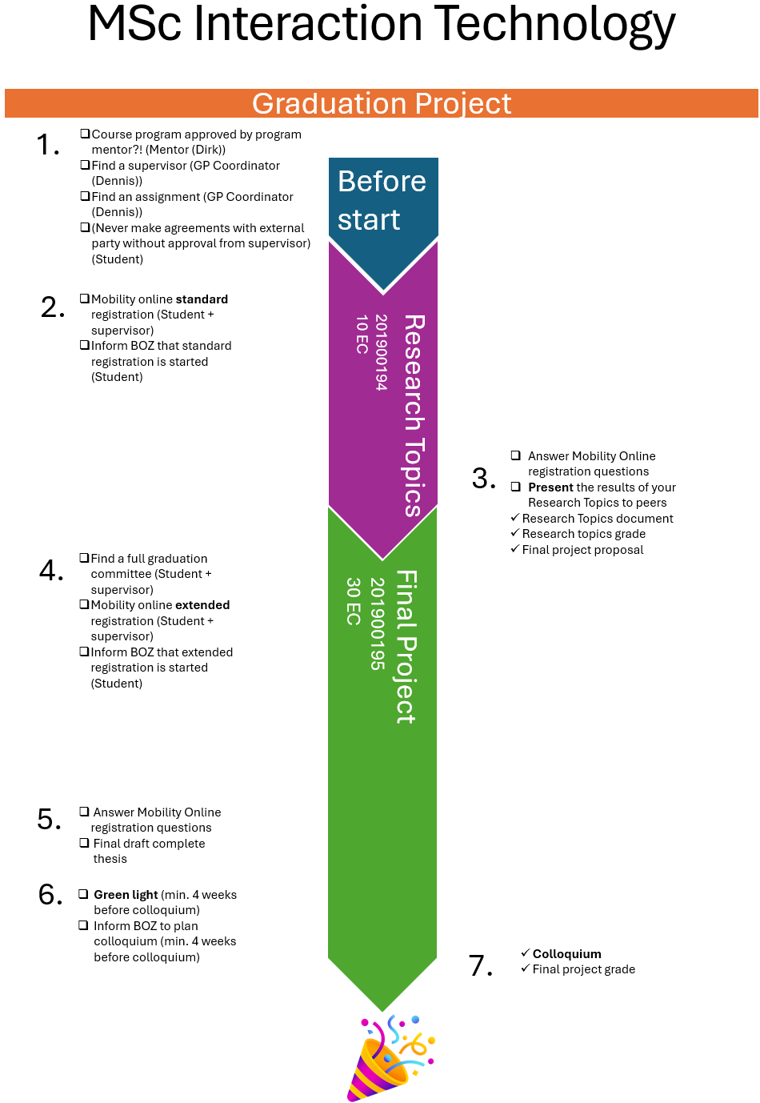Figure 1: A graphical representation of the Graduation Project for Interaction Technology

**Step 1 Before you start**

* Make sure that your Course Program has been approved by the program mentor Prof. Dr. Dirk Heylen (I-Tech), Dr. Mariët Theune (HCID). Check whether all your courses and grades are registered in Osiris and match with your approved program.
* Self-enroll for this Canvas environment I-TECH Research Topics & Final Project through: <https://canvas.utwente.nl/enroll/GT7HNE>.
* Before you start, make sure you have a supervisor for the Research topics. Together with the supervisor you will find/define an assignment. For an overview of I-Tech supervisors, please check [list of appointed examiners](https://universiteittwente.sharepoint.com/:x:/s/ExaminationBoardEEMCS2/EWXTrfqihZJIpaZ_eVgwKOcBpKkqHuc0oJ50vlUu9Jbaog) for I-Tech. If you need help with this step, please contact Dr. Dennis Reidsma.
* You will need to pick a topic for your Research Topics and Final Project. On the [website](https://www.utwente.nl/en/eemcs/hmi/hmi-teaching-folder/hmi-student-assignment-overview/)2 of the HMI group you can find a list of possible assignments. If you need help with this step, please contact [Dennis Reidsma](https://people.utwente.nl/d.reidsma).
  + - There is also an option to do an external assignment. For I-TECH students it is optional to do a final project with an organization outside the UT, while for EIT-HCID students it is in principle mandatory as explained in Section 1. In case of external final projects (especially when they take place outside the Netherlands) you can ask the people from the EEMCS internship office for advice on practical matters such as contracts, subsidies, financial support, visa, travel insurance etc.: https://www.utwente.nl/en/eemcs/internship/
* IMPORTANT: always make sure you have a supervisor from the HMI teaching staff before making any final agreements with a company! Also, do not sign any contracts with a company until you have checked that the contract complies with the university’s regulations, for example with respect to confidentiality; see Appendix 1. The internship coordinator has standard contracts available.

Also note: If you want to do an external final project at a company as an I-Tech student after having done an internship (20 EC) as part of your master programme, then you need to have special permission from the Examination Board.

**Step 2 Starting the Research Topics**

* Registration for Research Topics (I-Tech)
  + - Osiris:
      * I-Tech: Research Topics (201900194), 10 EC. To start with Research Topics (201900194) you need to have obtained 70 EC or more of your I-Tech programme.
      * HCID : EIT Research Topics (201800524), 4 EC.
    - Mobility Online: [Registration Form Graduation Standard](https://mobility-online.utwente.nl/mobility/BewerbungServlet?identifier=ENSCHED01&kz_bew_pers=S&kz_bew_art=OUT&aust_prog=INT_GRAD&sprache=en). The information you put in can be changed later.
  + Contact BOZ ([boz-itech@utwente.nl](mailto:boz-itech@utwente.nl)) to let them know you started the Registration Graduation Standard so they can check whether your file is complete, they don’t receive an automatic update when you submit something in Mobility Online.

**Step 3 Research Topics**

The main objectives of Research Topics are deepening the student’s understanding of the chosen research field for the Final Project, and further development of the student's research competencies. Research Topics typically entail an initial literature study and aim at the statement of a clear research or design question and planning for the Final Project.

After successfully completing the Research Topics, you will have the following:

* A Research Topics Document, which is separate from your Final Project document.
* A grade for your Research Topics.
* A proposal for your Final Project.
* Given a presentation about the findings of your research topics to your peers during one of the Research Topics peers presentations, planned each quartile.

**Step 4 Starting the Final Project**

The Final project is a 30-credit project, which rounds off the Master's programme. It is a research and/or development exercise. The Final Project is carried out individually. The final project may be carried out internally (within the UT) or externally (involving a commissioned assignment from a company or another higher education institution). Some projects are completed abroad. The project usually follows a preceding Research Topics.

The final project is a 'Master's test': in completing the project, the student demonstrates that he/she merits the Master of Science qualification. While the substance of the assignment focuses on a specified field of study, it is assessed on the basis of a number of general criteria laid down in the assessment form, following the course goals above.

* Form a complete graduation committee. For an overview of I-Tech supervisors, please check [list of appointed examiners](https://universiteittwente.sharepoint.com/:x:/s/ExaminationBoardEEMCS2/EWXTrfqihZJIpaZ_eVgwKOcBpKkqHuc0oJ50vlUu9Jbaog) for I-Tech. According to the latest rules in the Teaching and Examination Regulations, your Graduation Committee should be composed according to the following guidelines:
* *One I-TECH examiner from the research group Human Media Interaction.*
* *One I-TECH examiner from another research group within the University of Twente.*
* *One senior examiner.* A senior examiner has a University Teaching Qualification (UTQ) and has supervised five or more final projects as member of an I-Tech Graduation Committee. At least one of the committee members should be appointed as a senior examiner, meaning that this could be one of the above or a third additional member of the graduation committee.
* *The Graduation Committee may contain further examiners, who are experts in the topic of the Final Project.* This includes your daily supervisor. If you do a master thesis outside the University of Twente, your external supervisor is also part of the Graduation Committee.

For a full description of the requirements you can check the relevant articles (A3.7; A3.8; B4.2) in the [Education and Examination Regulations](https://www.utwente.nl/en/eemcs/education/rules-guidelines/eer-m/eer-m-2024/m-eer-24-25-itech.pdf).

Your daily supervisor probably has some suggestions if you don’t know, whom to ask as the other members of your Graduation Committee. It is furthermore possible to contact [Dennis Reidsma](https://people.utwente.nl/d.reidsma) for assistance in composing your Graduation Committee.

If you want to use the Tower Room (Citadel T200) during your Final Project, you can follow the instructions in Appendix 4 to get access.

* Registration for Final Project
  + - Osiris: The Final Project (201900195) requires that you have 10 EC or less left of your I-Tech programme.
    - Mobility Online: [Registration Form Graduation Extended](https://mobility-online.utwente.nl/mobility/BewerbungServlet?identifier=ENSCHED01&kz_bew_pers=S&kz_bew_art=OUT&aust_prog=GRAD&sprache=en).
  + Contact BOZ ([boz-itech@utwente.nl](mailto:boz-itech@utwente.nl)) to let them know you started the Registration Graduation Extended so they can check whether your file is complete, they don’t receive an automatic update when you submit something in Mobility Online.

**Step 5 Handing in the first draft of the final thesis**

* You hand in a complete draft of your final thesis.

**Step 6 Receiving Green light: getting permission to graduate**

* If your complete thesis draft is considered to be sufficient, your graduation committee will give their approval for your final thesis. This is called "green light declaration". This approval is not based on the truly final version of your thesis, but on a complete draft that the committee deems of sufficient quality.

You cannot get green light if parts of the thesis are still missing. The green light is basically a statement that you will get a sufficient grade for your thesis even if no further improvements are made.

* Contact BOZ to plan your colloquium by filling out a colloquium form (see Appendix 2). There should be **4 weeks** between the date of your colloquium and the moment you hand in the colloquium form to BOZ! They can inform you in more detail about this process.

For EIT students: please send an official document with your grades from your first year to BOZ. They need this in order to prepare your I-TECH diploma. You need to have at least 120 EC (including the credits from your first year) to get the diploma.

*Final version of thesis.*In the time between green light and final presentation, you can still make improvements to your thesis. The final version of your thesis should be sent to the committee a week before your final presentation. The university will expect a digital copy for your file and for the library; this needs to be uploaded before your final presentation. You will get information about this from BOZ.

**Step 7 Colloquium**

* First, you will present the main results of your research (30 minutes). Then there is time for questions from the thesis committee, but also from the rest of the audience. After the questions (which usually last 10-15 minutes) the thesis committee withdraws to discuss your work and determine your grade and fill in the assessment form (see Appendix 4). You join them after their deliberation so they can tell you the grade in private first and explain its motivation. When they come back to the public room, if you agree with it they will announce the grade in public, or else just that you have successfully graduated. In case of an on-campus presentation, the I-TECH-diploma then gets signed and handed over to you.
* The presentation is public and on the campus of the University of Twente. This means that you may have to remove any confidential information. Besides your thesis committee you can also invite fellow students, family and friends.
* Getting the diploma & diploma supplement: After your presentation, the UT supervisors will send the filled assessment form (see Appendix 3) to BOZ, who will register your thesis grade. BOZ will contact you via e-mail when your grade list (= diploma supplement) is complete; you can choose whether to pick it up in person or if you want them to send it to you. You will also get a copy of the assessment form.
  + If you did NOT get your I-TECH diploma at the time of your final presentation (for example, because your presentation was online) then you will have to pick it up in person at the university when it is ready, or authorize someone else to do this for you. You will get an e-mail from BOZ about this.

For EIT students: When you have the Master diploma from each of the two universities you attended, you can also get the EIT certificate based on those.

**Appendices**

1. **Confidentiality**

In principle, the master thesis is public and is published on the UT website. However, it is possible to keep it confidential for a limited period (2 years by default, up to a maximum of 5 years). A request regarding confidentiality should be sent by your advisor to the Programme Board of I-TECH (Randy Klaassen) before the start of the final project. Note that the university is obliged by law to store all final project reports (as well as internship reports) for a period of 7 years. Accreditation committees that assess the quality of the grading of the study programme must be able to read them. This also holds for confidential reports.

1. **Colloquium Announcement**

# Colloquium Form

**Degree Programme: Interaction Technology Academic Year:**

## Student Information

|  |  |
| --- | --- |
| Student number |  |
| Last name |  |
| First Name |  |
| Date of birth |  |
| Nationality |  |

## Correspondence address

|  |  |
| --- | --- |
| Place of residence |  |
| Phone number |  |
| Email address |  |

## Graduation Committee

|  |  |  |  |  |
| --- | --- | --- | --- | --- |
| **Function** | **Name** | **Affiliation** | **Department** | **Credit distribution[1]** |
| Chairperson |  | UT |  |  |
| Daily supervisor |  | UT |  |  |
| External supervisor |  |  |  |  |
| Additional member 1 |  |  |  |  |
| Additional member 2 |  |  |  |  |
| Additional member 3 |  |  |  |  |
| Additional member 4 |  |  |  |  |

## Master Thesis Description

|  |  |
| --- | --- |
| **Title** |  |
| **Description** |  |

## Final Presentation

|  |  |  |  |
| --- | --- | --- | --- |
| **Date** |  | **Time** |  |
| **Number of Attendants expected** |  | **Location (if already known)** |  |
| **Title of the presentation** |  | | |

## Course Programme approved

|  |  |
| --- | --- |
| **Course form is approved** | Yes/no |

## Courses still to be completed (if applicable)

|  |  |  |  |
| --- | --- | --- | --- |
| **Code** | **Course** | **Quartile** | **Number of weeks of full-time study** |
|  |  |  |  |
|  |  |  |  |

## Signatures

|  |  |
| --- | --- |
| **Student** | **Committee chairperson** |
|  |  |
| Date: | Date: |
|  |  |

***By this signature the committee chair grants the student the right to give a presentation about their master’s thesis project and to receive a grade for the final project after this presentation (green light declaration).***

1. Logo

   Description automatically generated with low confidence, Picture**Assessment Form**

**MSc in Interaction Technology Thesis Assessment**

Student Name: Student number:

Thesis Title:

|  |  |  |
| --- | --- | --- |
| **Assessment criteria**  (+aspects suggested to take into account) | **Assessment\*** | **Remark**  (optional) |
| **Content of thesis**   * Problem statement * Context and existing work * Discussion and argumentation * Results and conclusions * Recommendations |  |  |
|  |  |
| **Structure of thesis**   * Organization and structure * Clarity * References * Language |  |  |
|  |
| **Quality of work**   * Relevance * Originality * Complexity/volume of work * Contribution * Validation of design/product |  |  |
|  |
| **Process**   * Independence * Creativity * Problem solving * Planning * Interaction |  |  |
|  |
| **Scientific quality**   * Research question * Critical attitude * Scientific methods |  |  |
|  |
| **Oral presentation and defense**   * Clarity * Focus * Use of media * Answering questions |  |  |
|  |

* Describe your assessment of the criterion in short or use the following short forms: **n/a**: not applicable; **i**: insufficient; **--**: much below expectation; **-**: below expectation; **0**: meets expectation; **+**: above expectation; **++**: much above expectation

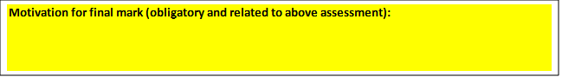 Name of Examiner 1: Name of Examiner 2:    
Signature: Signature:

Date: FINAL MARK Text Box 6, Textbox

1. **Step by step how to get access to Lab rooms**

* Go to the SESAM application (only available on VPN or internal UT network): [https://www.utwente.nl/en/service-portal/campus/campus-security-service/building-access-authorisation-during-and-outside-office-hours](https://eur02.safelinks.protection.outlook.com/?url=https%3A%2F%2Fwww.utwente.nl%2Fen%2Fservice-portal%2Fcampus%2Fcampus-security-service%2Fbuilding-access-authorisation-during-and-outside-office-hours&data=05%7C01%7Cd.p.davison%40UTWENTE.NL%7C4f673bef1b724a7aa7b108dac7f0199c%7C723246a1c3f543c5acdc43adb404ac4d%7C0%7C0%7C638042131299875773%7CUnknown%7CTWFpbGZsb3d8eyJWIjoiMC4wLjAwMDAiLCJQIjoiV2luMzIiLCJBTiI6Ik1haWwiLCJXVCI6Mn0%3D%7C3000%7C%7C%7C&sdata=3onYTo3hIg93FazA807QrOK%2BVLJiLG82KXla0lxJd70%3D&reserved=0)
  + Click the blue button “Request new access”

* + Select building “Citadel” and Organisation “EEMCS-HMI”

* + Find the key profile that you need access to (all room numbers in that group are listed in the entrances column).
  + You should also request access to the Citadel building: “CI - (students) Main entrance during the day”
  + If you want a specific lab room (e.g. H104, H106), you should first check with the Lab administration team or Daniel Davison if it is available.
    - CI - “Room Number”



* + **Note**: There is also a combination request if you need to be in the Tower room (T200) and the Main lab (H107 & H109): “CI - HMI - IA - Lab”



* + For the chosen row, click the “EEMCS-HMI” in the first column, which opens a popup
  + Set the start and end date for when you want to have access to the room.
  + Briefly describe the reason for the access request and if applicable mention your supervisor.
  + You can only make one request each time. Click “Save” or “Save and request another” to send the request

* + Repeat the process for additional access to key profile groups.
* The request has to approved by Daniel Davison
  + As soon as he has done this, you will be notified by email that from that moment on you have access
* When you are in Citadel and want to access your room with your student card, make sure to activate it at the main entrance
  + There is a scanner with the label “Daily card activator” in front of which you need to hold your card to be able to use it to access the rooms

1. In case of equal supervision, credits are equally divided to the supervising parties. In case of assessment, the credits are assigned to the main supervisor.