3D simulation of flow and heat transfer in honeycomb channels for a heat storage system: an important section of the EU-funded project ABraytCSPfuture
Solar energy is quickly developed and deployed for power generation, achieving decarbonization and low-carbon footprints. Correspondingly, concentrated solar power (CSP) is a technology that is suitable for large-scale solar utilization and is easy to scale up. However, thermal energy storage (TES) systems have to be involved to overcome the inherent shortcomings of solar energy e.g., intermittence, supply-demand mismatch, etc. To date, TES could be achieved by sensible heat storage (SHS), latent heat storage(LHS), and thermochemical heat storage (TCES) methods, while TCES has the largest energy storage density (~500 kWh/m³) in comparison to SHS (~50 kWh/m³) and LHS (~100 kWh/m³). Our EU-funded project ABraytCSPfuture aims to develop air-Brayton cycle CSP future plants with redox oxides-based thermochemical heat exchangers to achieve high-efficiency and stable power generation. This master thesis will be an important part of this leading-edge project.
(a) 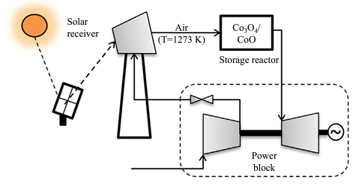 | (b) 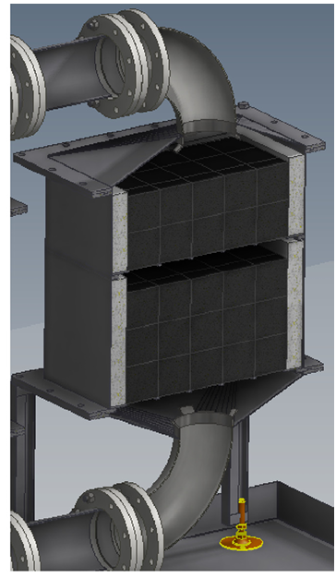 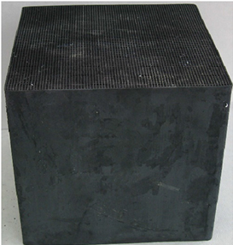
Figure 1: (a) Concentrate solar power plant with TCES technology, (b) A TCES reactor
Figure 1(a) shows a typical CSP with redox-based TCES technology which can achieve high temperatures of >1000 °C to promote the efficiency of the air Brayton cycle [1]. The reactor is the core component of TCES, and flow and heat transfer in the reactor play a vital role in determining the reactor's performance. In the literature, honeycomb-structured thermochemical reactors have been proposed. Then, solar-heated air flows through the honeycomb channels and transports heat to reactive materials on honeycombs for endothermic/exothermic reactions [2, 3]. Therefore, it is very important to investigate and optimize the flow and heat transfer in honeycomb channels. In this thesis, it is planned to conduct such investigations through 3D simulation (ANSYS Fluent), shown in Figure 2.
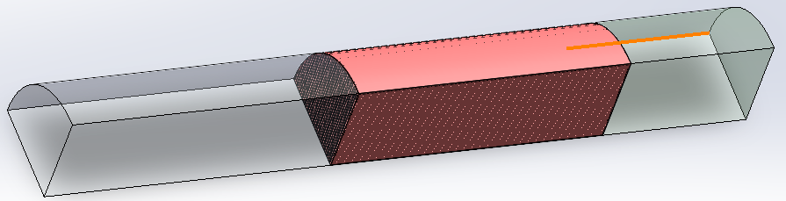
Figure 2 A flow channel with honeycomb
The specific tasks are temporarily planned as:
- Create 3D computation domains and generate meshes
- Set up the flow model correctly by comparing it with some experimental measurements
- Investigate and optimize the flow by changing the property of honeycombs (e.g., uniform porosity by monolithic honeycomb, gradient porosity by stacking several honeycombs)
- Add the heat transfer model to the flow model, and investigate the temperature of honeycombs, revealing its thermal energy storage performance
- Further, add the chemical reaction model to the flow and heat transfer model, investigating its thermochemical heat storage behavior (optional depending on time)
If you are interested, please feel free to contact Dr. Zhen Cao (z.cao@utwente.nl) or Dr. Abhishek Singh (a.k.singh@utwente.nl) at the Department of Thermal & Fluid Engineering, University of Twente. You will be working in an active team of PhDs and postdocs.
[1] Singh A, et al. Solar thermochemical heat storage via the Co3O4/CoO looping cycle: Storage reactor modelling and experimental validation. Solar Energy. 2017;144:453-65. [2] Karagiannakis G, et al. Cobalt/cobaltous oxide based honeycombs for thermochemical heat storage in future concentrated solar power installations: Multi-cyclic assessment and semi-quantitative heat effects estimations. Solar Energy. 2016;133:394-407. [3] Tescari S, et al. Experimental evaluation of a pilot-scale thermochemical storage system for a concentrated solar power plant. Applied Energy. 2017;189:66-75.

