Optimizing Waste Heat Recovery in Green Hydrogen Production: Design and Techno-economic Analysis

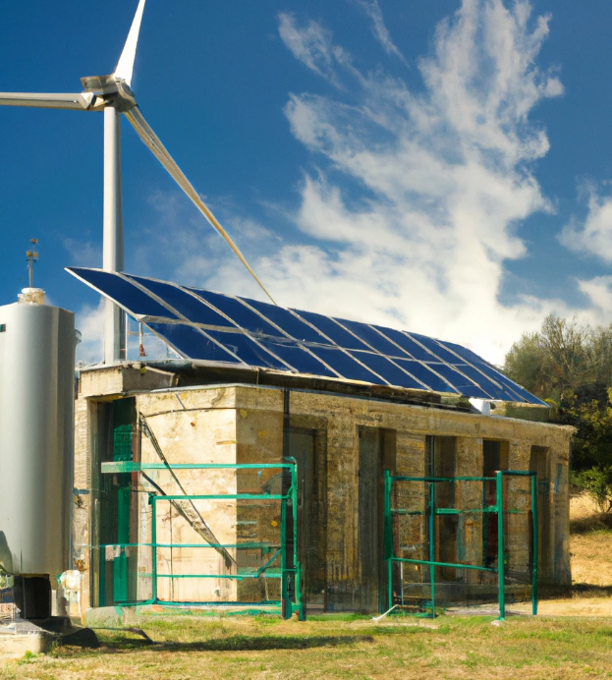

Join our research project in collaboration with Suzlon and contribute to developing sustainable energy technologies by optimizing waste heat recovery in green hydrogen production. Seize this opportunity to work with industry professionals and make a tangible impact on the future of hydrogen energy.

Introduction
Enhancing the green hydrogen economy is crucial with the rising global demand for hydrogen. Recovering waste heat generated during hydrogen production can improve green hydrogen's profitability. In collaboration with Suzlon, this research project aims to design, model, and evaluate waste heat recovery systems for Alkaline electrolyzers (temperature in the range of 60-70°C), considering Levelized Cost of Heat (LCOH) for capacities of 1, 5, and 500 MW.

Research questions
- What are the viable waste heat recovery options for low-temperature heat (60-70°C)?
- What is the maximum recoverable waste heat amount?
- How do the available heat recovery options perform in terms of techno-economic analysis?
- What are the most effective ways to store and utilize this waste heat for maximum techno-economic benefit?

Objectives
The research project, which is an MSc assignment for SET students, will focus on the following:
- Developing and modeling innovative heat recovery configurations integrated with thermal energy storage systems for low-temperature electrolyzers
- Evaluating and optimizing the most promising and advanced integrated configurations for optimal operating performance
- Conducting a techno-economic analysis of the designed thermal storage system

Role of SUZLON
Suzlon will contribute to the project by:
- Providing essential data on current installations, energy supply, and demand profiles for modeling and validation. Suzlon will offer 10-minute input power data for wind turbine plants and/or hybrid plants with wind turbines and PV
- Appointing a Suzlon representative as an external supervisor to guide and provide feedback during regular meetings and attend the final Master's Thesis defense

