Master’s Assignment: Create Functional Capsules by Powder Coating Droplets.
Microcapsules are widely used in medicines and food to provide protection and controlled release of many active ingredients such as peptides, mRNA, and vitamins. The current way to produce microcapsules requires the use of organic solvents. Using solvents is polluting and causes significant loss of bioactivity of the active ingredients, resulting in less effective medicine. In this project, we will investigate a novel processing method, powder coating technology, to generate microcapsules without using any organic solvent. When successful, we can better preserve the bioactivity of medicines and food ingredients and hugely reduce the environmental impact of medicine production.
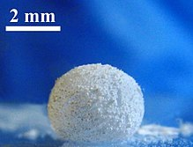
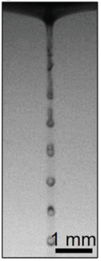
Figure 1. Photograph showing a millimeter water droplet was coated by a layer of hydrophobic polymer powder forming the well know liquid marble. Wikipedia.
Figure 2. Image shows a liquid jet from a nozzle and break into monodisperse droplet. In this project, you will design a setup to coat the droplets with powders to create high quality capsules without using solvent.

NWO-funded project:
-Engage in a curiosity-driven and fundamentally creative project supported by the Dutch Research Council (NWO). You will have ample funding to explore various ideas for solving the problem.

A friendly and supportive team:
-You will be part of the FM2 (Fluid Mechanics for Functional Material) team led by Claas Willem Visser within the EFD (Engineering Fluid Dynamics) group led by Kees Venner.
- Collaborate closely with fellow Master’s students, PhD candidates, offering mutual support. Have the opportunities to share research findings through regular academic presentations. Gain exposure to the diverse and valuable research within the team.

Combined effort to solve problems:
-Solving real-world problems often requires expertise from various fields. Similarly, this assignment is a collaborative project of different topics that will enhance your understanding of fluid dynamic, material science, and biomedical applications. The specific content can be tailored to your skill set and the results. Your daily supervisor, Jieke Jiang, will work closely with you to provide guidance and support.

Start in or after October. If you are interested, please email to j.jiang-1@utwente.nl

Ref. High‐Throughput Fabrication of Size‐Controlled Pickering Emulsions, Colloidosomes, and Air‐Coated Particles via Clog‐Free Jetting of Suspensions, J Jiang, AT Poortinga, Y Liao, T Kamperman, CH Venner, CW Visser, Advanced Materials 35 (13), 2208894

