Assignment description
Experimental study of the heat transport in multi-layer graphite thermal router

Abstract

When talking about thermal management, one vivid example is the temperature control at our houses, where we like to keep the environment warm in winter and cool in summer. Thermal management in electrical devices is much more complex. As an example, in the GoPro camera, to save space and ensure fast signals, everything is tightly packed. Processing and storing data generate heat due to the power dissipated by thousands of transistors, while lenses, microphones and batteries need to stay at room temperature to prevent damage. To date, commercial thermal management systems are mostly based on active liquid or air convection, which implies a bulky flow management system, costly maintenance, large thermal inertia and hefty weight. In contrast, solid-state systems are light-weight, compact, low-maintenance, and vibrations-free. However, the low thermal-conductivity of existing thermal conduits (e.g., bulk Cu 400 W·m⁻¹·K⁻¹) limits their commercial application. In this project we are developing a unique graphitic thermal conduit (CTC) with extremely high thermal conductivity (~2000 W·m⁻¹K⁻¹) capped with ultra-high insulating 2D heterostructures for heat losses reduction (Fig. 1). One of the main engineering challenges in this project is the challenge is to measure accurately these high thermal conductivities in-plane on the micron-think thermal conduits.
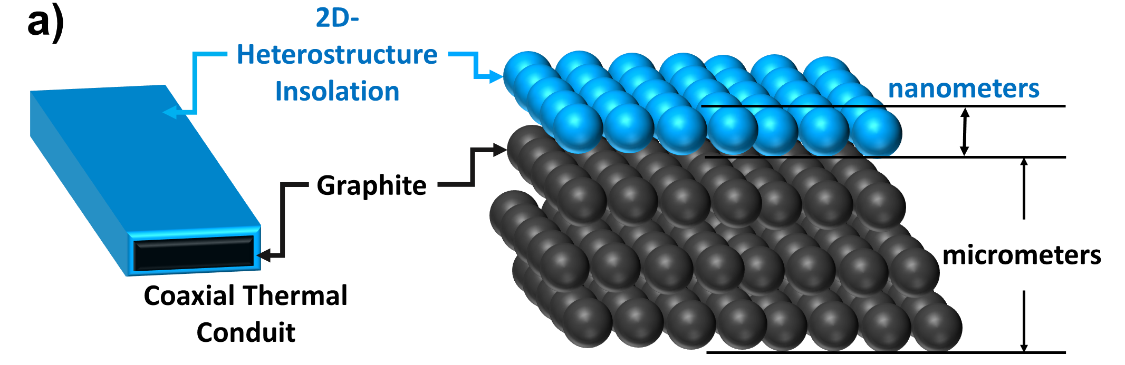  Figure 1 Schematic view of the coaxial graphite-based thermal conduits (left) and the 2-layered model system (right). | 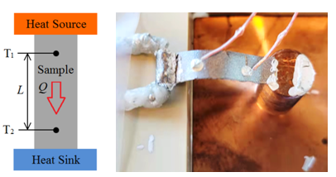  Figure 2 Principle and built setup for steady state thermal conductivity measurement
For the thermal conductivity measurement, the classical steady state method was adopted in our work. The setup has been preliminarily built up (Fig. 2) and the measurements on several foils have been carried out. There are several challenging tasks for the student:
1) Design a reusable or removable anchoring heat element. The intimate and robust connections between different parts, the heater, heat sink, thermocouples and samples, are critical to realizing an interference-free heat flow. The 3D printing technique can be used for designing and making complex pieces.
2) Heat losses. Analyze systematically the possible heat loss terms during the measurement and manage to eliminate them by optimizing the experimental parameters.
3) Validation of the set-up and testing of the thermal properties under different working conditions such as under compression or during temperature cycling tests.

Profile & requested skills:
We are looking for a highly motivated engineering student (Mechanical Engineering, Structural Engineering, Mechatronics, Industrial Product Design, Materials Engineering) with a strong interest in experimental physical measurement and materials engineering. Interpersonal skills, dynamism, rigor and teamwork abilities will be appreciated. Candidate with mechanical design and 3D printing experiences are preferred.

Location: Thermal Engineering Group
Supervisor and Daily supervisor:
Prof. Gerrit Brem
Daily supervisor: Dr. Xinming Xin – Postdoctoral Fellow
Collaboration:
Dr. Jimmy A. Faria A. Associate Professor Email: j.a.fariaalbanese@utwente.nl
Dr. M. Muñoz Rojo researcher at the National Research Council of Spain (Madrid)

