Bachelors Project:
Ferrofluid-infused slippery surfaces for magnetic droplet transport.

Overview

Sliding droplets are everywhere: from rain on car windshields, to industrial manufacturing and medical sensors. Two key objectives for many of these systems are 1) surfaces that are superhydrophobic, and 2) control over the motion of droplets on these surfaces. One clever solution to the first problem is the so-called “slippery surface”: a textured surface filled with a thin layer of hydrophobic lubricant. These slippery surfaces allow water drops to roll across them without making contact with the solid beneath, making them very low-friction. Recently, members of our group collaborated to create slippery surfaces that not only allow drops to roll, but also allow precise control over drop motion¹. By adding ferromagnetic nanoparticles to the hydrophobic lubricant, the surface becomes magnetically active. In this way, water droplets can be transported, divided, coalesced, and made to dance simply by guiding them with a magnet.
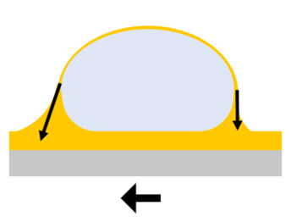
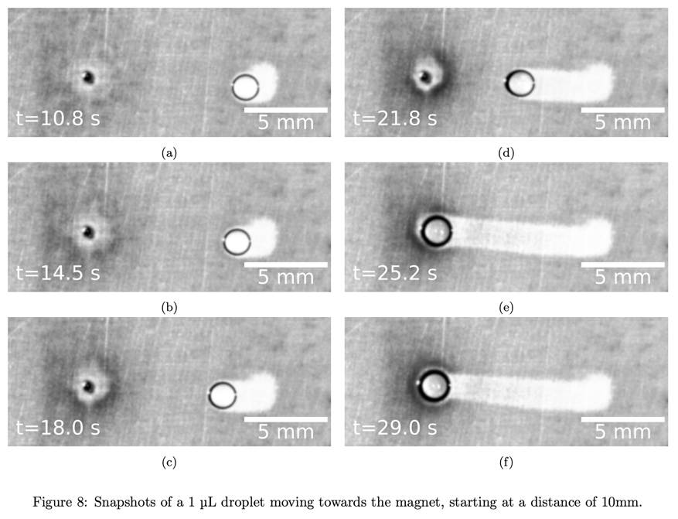
Water Drop
Magnet

Research Objective

This phenomenon could prove incredibly useful in many fields, but it is still new and poorly understood. Your research objective would be to initiate drop motion atop these ferrofluid-infused slippery surfaces using a magnet, and then to track and characterize this motion. A basic setup and tracking software already exists at the PCF (see figure from Daniël Logmans bachelor thesis)². You would continue this work by exploring parameters such as magnetic field strength, lubricant viscosity, and droplet size in order to get a better understanding of the magnetic and viscous forces acting on the drop while it moves. Depending on your interests and expertise, you could also begin to model the motion (if you enjoy mathematics and coding), or to build a more advanced setup for experiments (if your interests are more towards engineering).

Learning Objective

In addition to the standard learning objectives for a bachelor’s project (research planning, academic writing, data presenting, how to work in a lab environment, etc.), you will:
- Learn basic chemical-lab skills (pipetting, preparation of ferrofluid dispersions, etc.)
- Learn how to use a home-built camera setup and Matlab tracking software
- Learn fundamental concepts of capillarity and how forces act on moving drops
- Depending on your interest, you may write some analysis code in Matlab or Python
- Depending on your interest, you may improve the home-built experimental setup

Contact Information

- Daily Supervision: Dr. Amy Stetten (a.z.stetten@utwente.nl)
- Supervision: Prof. Dr. Frieder Mugele (f.mugele@utwente.nl)

Literature
- Zhang, J. et al. Wetting ridge assisted programmed magnetic actuation of droplets on ferrofluid-infused surface. Nat Commun 12, 7136 (2021).
- Daniël Logmans Bachelor Thesis

