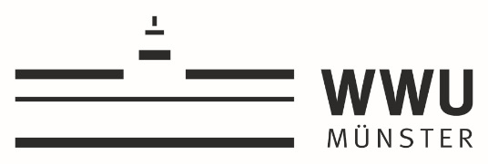

Strategic Collaboration Grants 2022-2023

APPLICATION FORM

Title:

Applicants
Applicant | Faculty/Unit | Name/position contact person
- UT Partner
- WWU Partner

Description of the Action (up to 3 pages)

- Introduction
The introduction should provide evaluators with a clear understanding of the challenge addressed by your proposal and its expected results. In addition, it should also include a brief description of the researchers involved and their contribution to the joint initiative.
- Key objectives
Describe the objectives and the expected results of your proposed work. Are they measurable and verifiable? Are they realistically achievable? Describe how your project goes beyond the state-of-the-art, and the extent the proposed work is innovative.
- Core activities
Describe and explain the overall methodology and implementation plan of your proposal. Explain how this will enable you to deliver your project’s results. Refer to any important challenges you may have identified in the chosen methodology and how you intend to overcome them. Refer to infrastructure, facilities, products, services, … of both universities relevant for the joint initiative.
- Timeline
Describe the timing of each component of the implementation plan of your proposal, including milestones (if relevant) and results. This can also be done with a chart.
- Exploitation Plan
Describe the measures planned to exploit the project’s results.

Budget plan

Budget items | EUR
1.
2.
3.
4.
…
…
…
Total requested budget

Motivation (up to 5 pages)
Describe how the proposed action contributes to the call’s objectives.

How will the project contribute to the strategic aims of strengthening the collaboration and visibility of both universities? Please describe possible access to new (inter)national networks and/or stakeholders.

How would your project’s results make an impact on society?

Describe intended follow up projects and opportunities to obtain third party funding.

What is the history and what are the innovative features of the collaboration?

Why is joint expertise of both partners essential for the achievement of the project’s results?

How does the collaboration valorize synergies between the teams and the structures involved?

Why is the project relevant for both UT and WWU? Please describe a short- and mid-term perspective.

