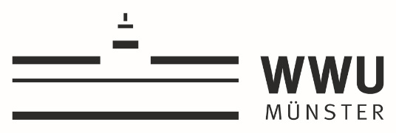

Young Researcher Project Grants 2022-2023

APPLICATION FORM

Title:

Applicant and Supervisors
Applicant | Faculty/Unit | Name/position
- UT Supervisor
- WWU Supervisor

Description of the Action (up to 3 pages)

- Introduction
The introduction should provide evaluators with a clear understanding of the challenge addressed by the proposal and its expected results. In addition, it should include a brief description of the supervisors involved and their contribution to the initiative.
- Key objectives
Describe the quality and pertinence of the project’s research and innovation objectives (and the extent to which they are ambitious, and go beyond the state of the art).
- Core activities
Describe and explain the overall methodology and implementation plan of your proposal. Explain how this will enable the PhD-student to deliver the project’s expected results. Refer to any important challenges you may have identified in the chosen methodology and how these can be overcome. Refer to infrastructure, facilities, products, services, of both universities relevant for the project.
- Timeline
Describe the timing of each component of the implementation plan of your proposal, including milestones (if relevant) and results. This can also be done with a chart.
- Exploitation Plan
Describe the planned measures to exploit the project’s results.

Budget plan

Budget items | EUR
1.
2.
3.
4.
…
…
…
Total requested budget

Motivation (up to 5 pages)
Describe how the proposed action contributes to the call’s objectives.

Describe the research infrastructure and the tailor-made supervision environment provided for the PhD-student for the duration of the grant.

What is the history and what are the innovative features of the existing collaboration?

Why is joint expertise of both partners essential for the achievement of the proposal’s results?

How does the proposal valorize synergies between the teams and the structures involved?

Why is the project relevant for both UT and WWU? Please describe a short- and mid-term perspective.

